Micro:bits

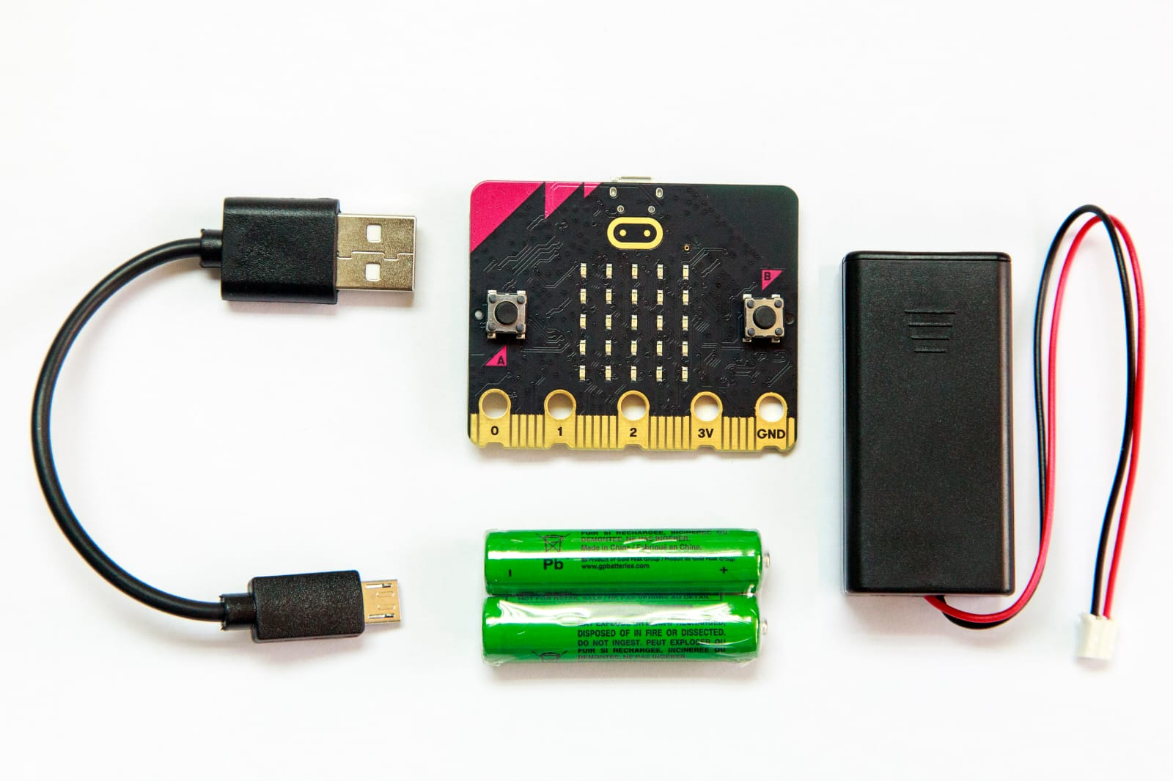

Name/Names:
Class:

Index
1.Introduction 3
Requirements 3
2. Anatomy of a Micro:bit 4
2.1 The front of the Micro:bit 4
2.1.1 A & B buttons (1) 4
2.1.2 In- and output rings (2) 4
2.1.3 LED- display (3) 4
2.2 The back of the Micro:bit 5
2.2.1 De accelerometer (4) 5
2.2.2 Compass (5) 5
2.2.5 Micro-USB connector (8) 6
2.3 Version 2 Micro:bits 6
2.4 Groove shield 6
3. Assignments 8
Assignment 3.1 Let there be light! 11
Assignment 3.2 Number or letter? 12
Assignment 3.3 Hot or cold? 13
Assignment 3.4 …..if, then…..? 15
Assignment 3.5 Which direction? 17
Assignment 3.7 ….and the duck appears! 20
Assignment 3.7 Rock, paper, scissors! 22
Assignment 3.8 Ultrasonic sensor 28
3.8.1. Preparation Excel 32
3.8.2 Application Micro:bit and Excel 34
4. Projects 39
4.1 Follow the line! 39
4.2. Space invaders 43
4.3 Micro:bit and Excel 50
4.3.1 First code (Radio transmittor) 50
4.3.2. Second code (radio receiver ) 52
4.4 Who’s the fastest? 55
5. Final project 64

1.Introduction
Over the next two weeks, you'll be working with Micro:bits. Micro:bits are mini computers that allow you to get acquainted with programming in an accessible way. During the upcoming lessons, you will discover and apply the different sensors and possibilities of the micro: bits.

We will use the website https://makecode.microbit.org/ On this site you will write the code/programs for the Micro:bits.

Requirements
- Micro:bits set (Micro:bit, micro-USB cable and a battery pack)
- Laptop
- Alligator clips
- Groove shield
- External sensors
- MaqueenPlus robot

2. Anatomy of a Micro:bit
Below In Figure 1 is an outline of some of the different parts of the Micro:bit and their functions.
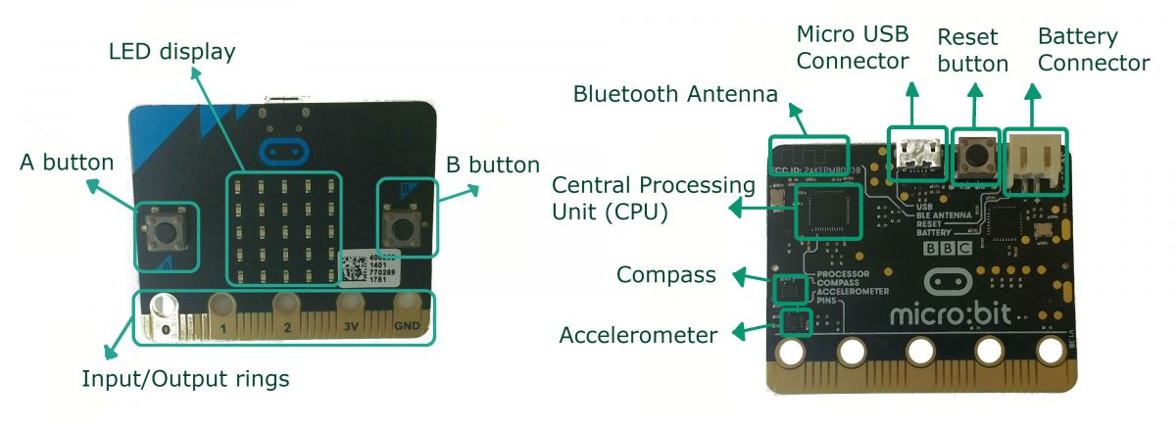
Figure 1. Micro:bit front and back view

2.1 The front of the Micro:bit
Figure 2 showcases the front of the Micro:bit with the main three components; 2 buttons (1), in- and output rings (2) and an LED display (3).
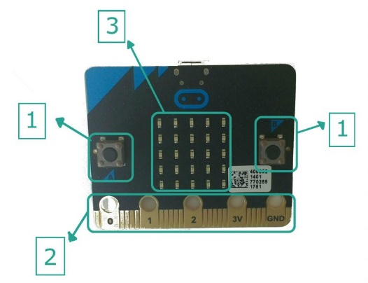
Figure 2. Front of the Micro:bit

2.1.1 A & B buttons (1)
Two separate, built in push buttons (A and B) found on the front of the Micro:bit. These can be programmed to trigger events on the device and be used to become an input device, which can be used for interactive projects.

2.1.2 In- and output rings (2)
The golden, external connectors, or rings, are found at the bottom of the Micro:bit. The versatile pins, 0, 1 and 2, can be used to connect additional input and output devices such as lights, sensors, etc. The 3V pin is a power supply ring, where external devices can be attached to supply to or use power from the Micro:bit. The final ring is the ground ring (GND), which is used to ground the device when the 3V is applied, so it does not short the circuit.

2.1.3 LED- display (3)
The 25 red LEDs (Light Emitting Diodes) found on the front of the Micro:bit in a 5×5 square array, can be programmed to display animation, images, symbols or text. Each individual LED is programmable to be on/off at any given time.

2.2 The back of the Micro:bit
The back of the Micro:bit consists of 6 different components, as shown in Figure 3; the accelerometer (4), compass (5), CPU (6), Bluetooth antenna (7), micro-USB connector (8), reset knop (9) and the battery connector(10).
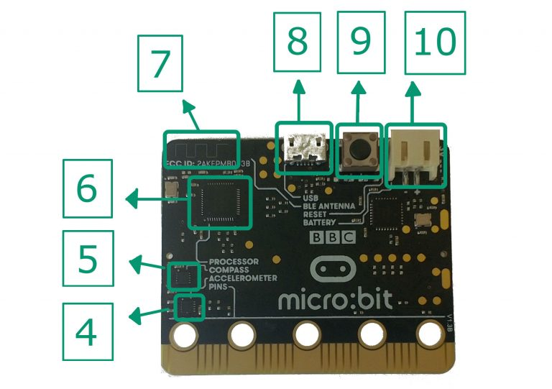
Figure 3. Back of the de Micro:bit

2.2.1 De accelerometer (4)
The accelerometer senses and measures changes in direction or movement of the Micro:bit itself along three axes:
X – tilting from left to right.
Y – tilting forwards and backwards.
Z – moving up and down
2.2.2 Compass (5)
The magnetometer helps the Micro:bit to detect and measure any changes in movement and direction through sensing magnetic fields, just like any other compass.
2.2.3 CPU (6)
The CPU (Central Processing Unit) is commonly known as the ‘brains’ of a computer. The CPU acts as a memory store for functional sequences and instructions for input/output devices into the Micro:bit and executes this stored data when activated.
2.2.4 Bluetooth antenna (7)
The antenna allows the Micro:bit to communicate wirelessly via Bluetooth to other devices with BLE (Bluetooth Low Energy) or between other Micro:bits. An example of a device that can be used is a BLED 112 Smart Dongle which allows the Micro:bit to link wirelessly to a computer.
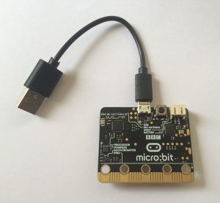
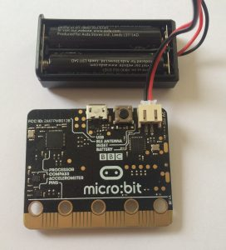
2.2.5 Micro-USB connector (8)
The micro USB Connector found on the back of the Micro:bit allows it to be connected to a computer via a USB port. This enables coding to be edited and transferred onto the Micro:bit and receive power from the computer, allowing it to function without being connected to the battery pack, see Figure 4.
2.2.6 Reset button (9)
When this button on the back button is pressed, any code that has been downloaded on the Micro:bit will be reset so the coding/programme will start from the beginning.
2.2.7 Battery connector (10)
When the battery pack is plugged into the battery port on the back of the device, it allows coding on the Micro:bit to be used away from the computer, without being plugged in via the Micro USB Connector, see Figure 5.
Figure 4. Micro-USB connector with Micro:bit

2.3 Version 2 Micro:bits
Figure 5.Micro:bit connected to the battery pack
The micro: bits V2 have been expanded with built-in speakers, a microphone and a touch sensor, see Figure 6. These Micro:bits can be recognized by the golden logo.
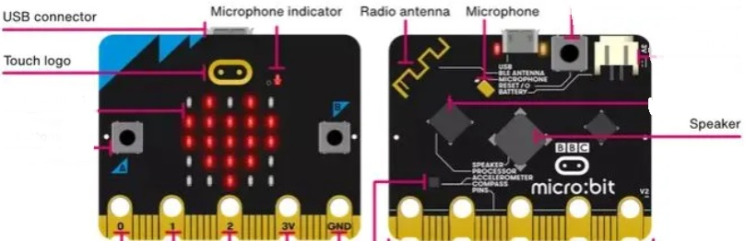
Figure 6. Micro:bit v2 with extensions

2.4 Groove shield
The groove shield, Figure 7, can be used to connect extra sensors to the Micro:bit. The different sensors that are available at school, are listed down below:
- Groove gesture
- Rotary angle
- Speaker
- Ultra sonic ranger
- LED
- Digit display
- EMG detector
- Servo

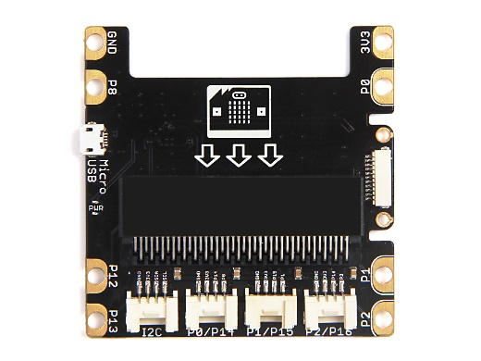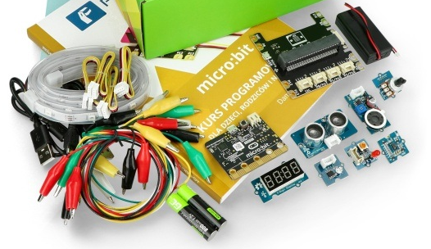
Figure 7. Left: Groove shield, Right: sensors

3. Assignments
We'll start by writing an easy code. Follow these steps:
1. Connect the Micro:bit to your laptop with the USB connection
2. Go to the website https://makecode.microbit.org/#
3. Open a new project
4. Give your project a name:
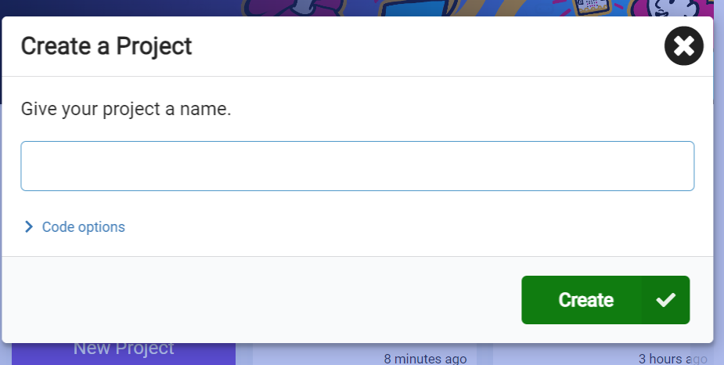
5. You get the following screen:
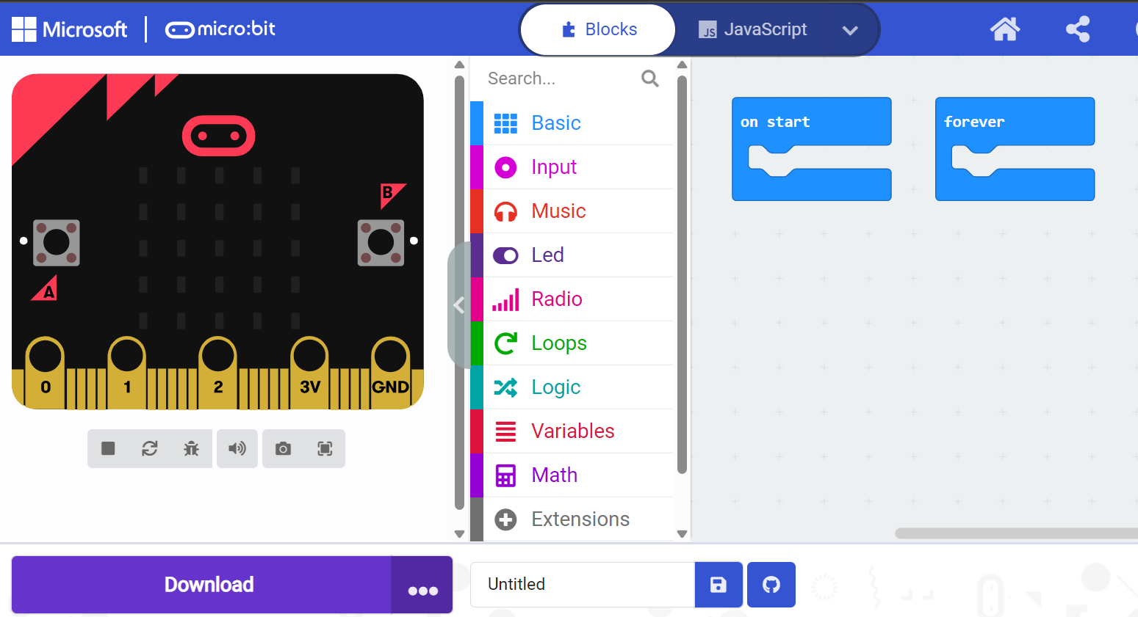
This screen is divided in to three main parts; on the left you can see an "example" Micro:bit. You can use this to see what the result is of the code you have written. In the middle, you can see different blocks that we can choose from to write our code. Finally, on the right, is our work field.
6. We don’t need the “on start” block so we can delete it by dragging it to the tools, as shown in the figure below:
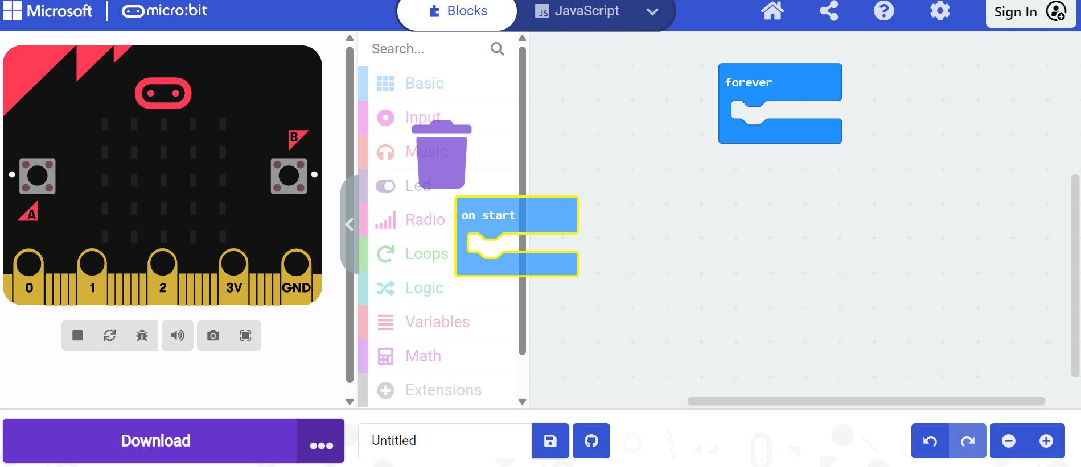

7. Now we are go to the basic blocks. We can choose between 9 basic blocks. In this example exercise we’re going to use show string “hello”. Drag this block into your work field, as shown in the figure below:
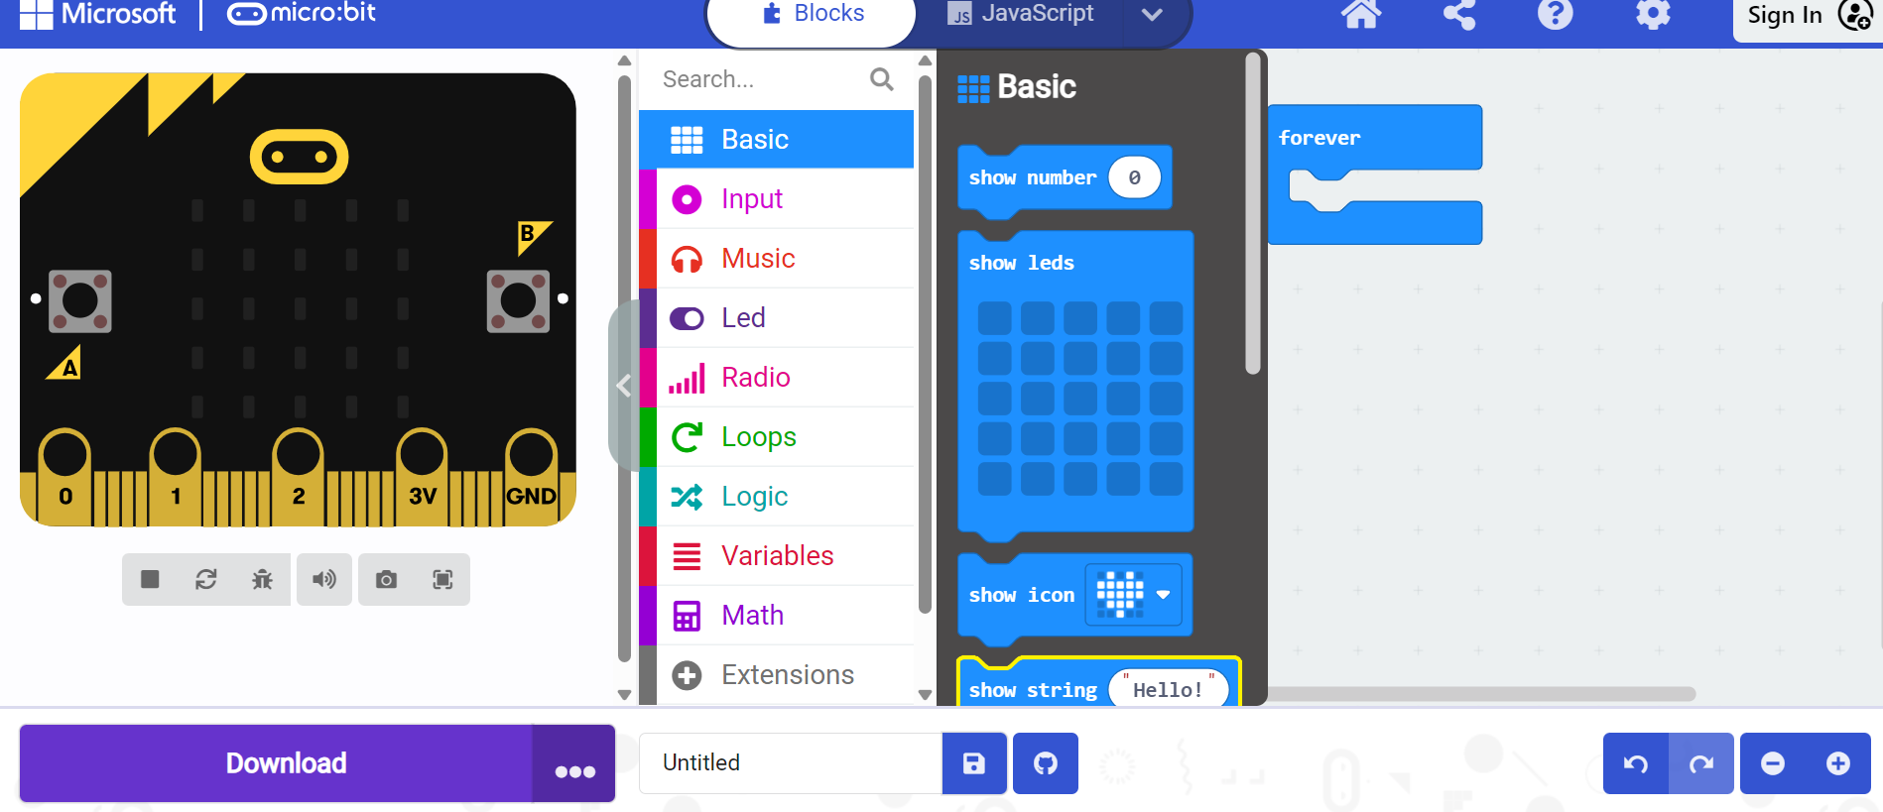
8. Drag the “show string” block into the forever block:
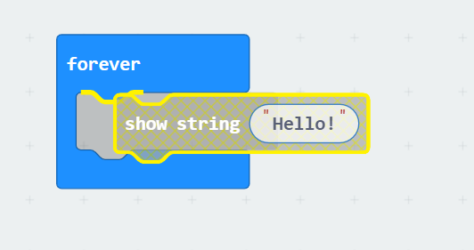
9. Change the “hello” to your own name
10. On the left side of the screen you see your own name appear on the example Micro:bit:
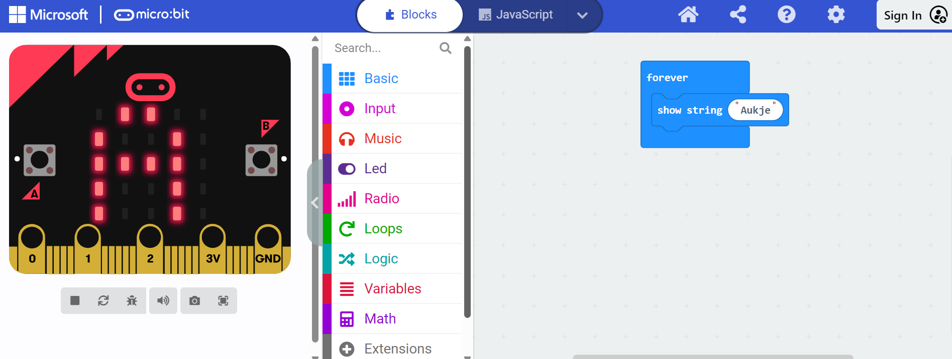
11. Click the download button
Depending on your settings, your code will be placed directly on the Micro:bit or it will end up in the download folder. If this is the case, you can follow these steps:

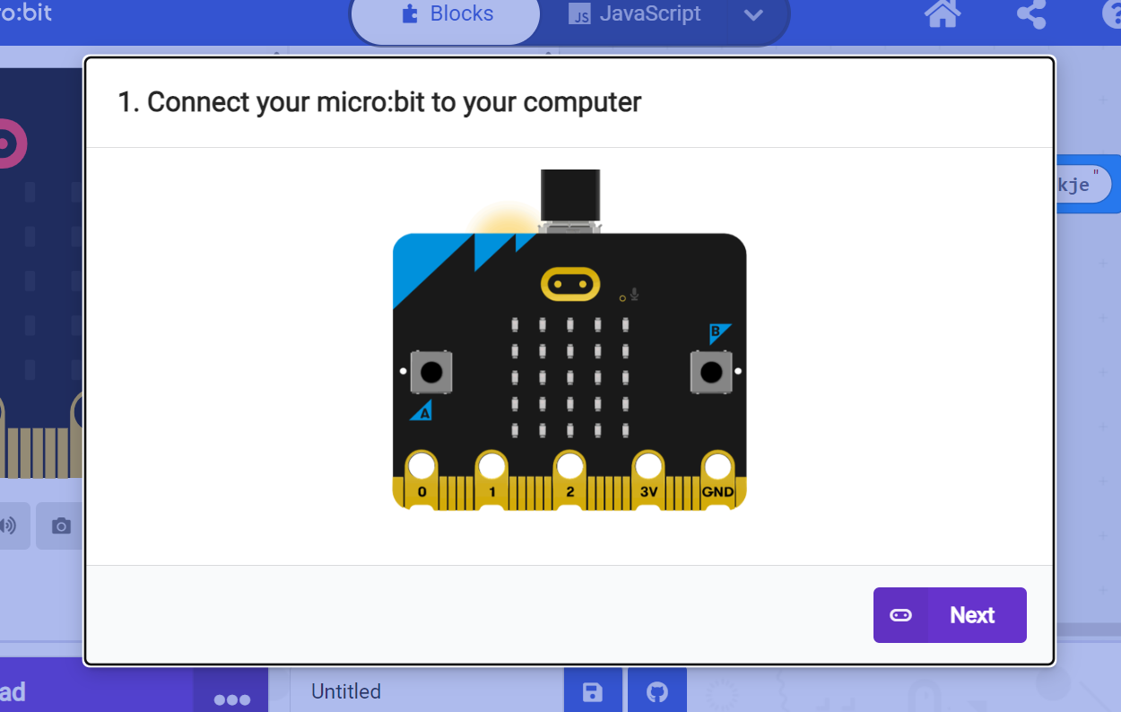
Click on next, the following screen will appear:
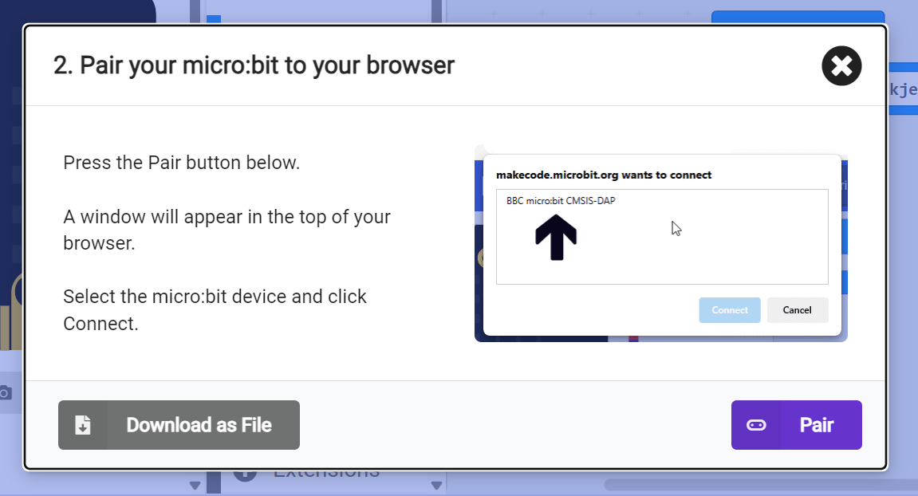
Click on "pair”, your Micro:bit will now be connected to your computer and the program will be downloaded on it. You'll notice that a small light will flash on the back of your Micro:bit. This means that the program is downloaded on the computer.

Assignment 3.1 Let there be light!
In this assignment we are going to measure the light level with a Micro:bit. To do this, we need the Input and the Led tools from the Tools bar.
1. Create a new project
2. The Micro:bit has to measure the light level all the time, so we use the forever block for this. The “on start” can be removed.
3. Go to led and select "plot bar graph of", place it in the work field. With this we are going to display a bar graph on the micro: bit, which can represent the level of the light. See image below:
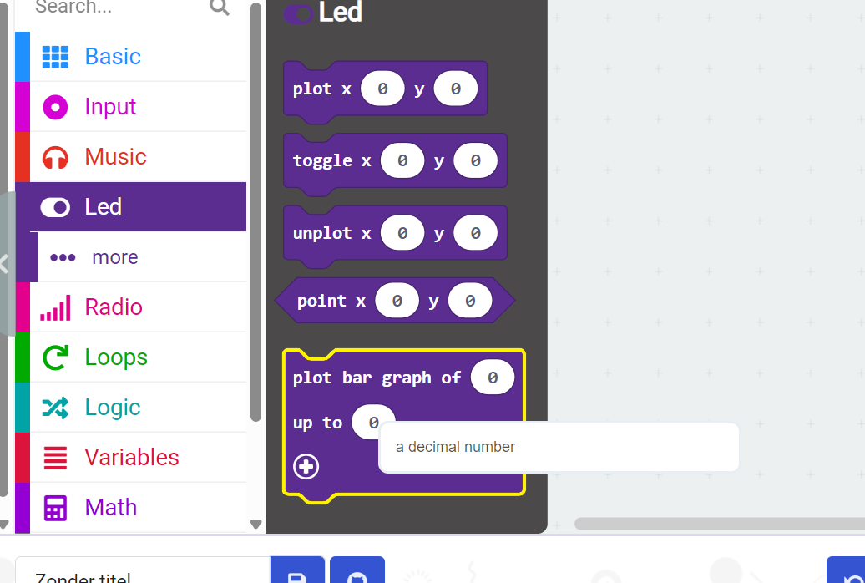
4. Go to the Input and select the option, “light level” and drag it to your work field:
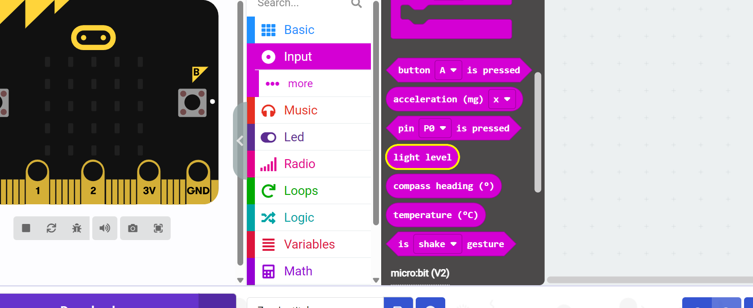
5. Place the block in the first input, the value input (since we are going to measure the light level), as shown in the figure below. We are not going to adjust the other input (the height) because it determines the height of the graph:
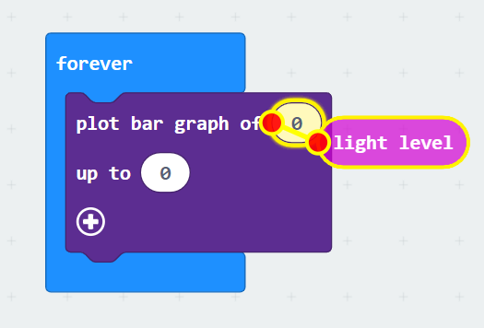
6. Test your code on the Micro:bit example. If this is okay, you can download it. Shine a flashlight on the Micro:bit (or hold it to a lamp) and place it in the dark as well, see what the Micro:bit indicates.

Assignment 3.2 Number or letter?
Part A.
We are going to make the Micro:bit show a number when button A is pressed, follow these steps:
- Create a new project

- Remove the default blocks (on start & Forever), then go to input and choose "on button A is pressed" and drag it to your work field:

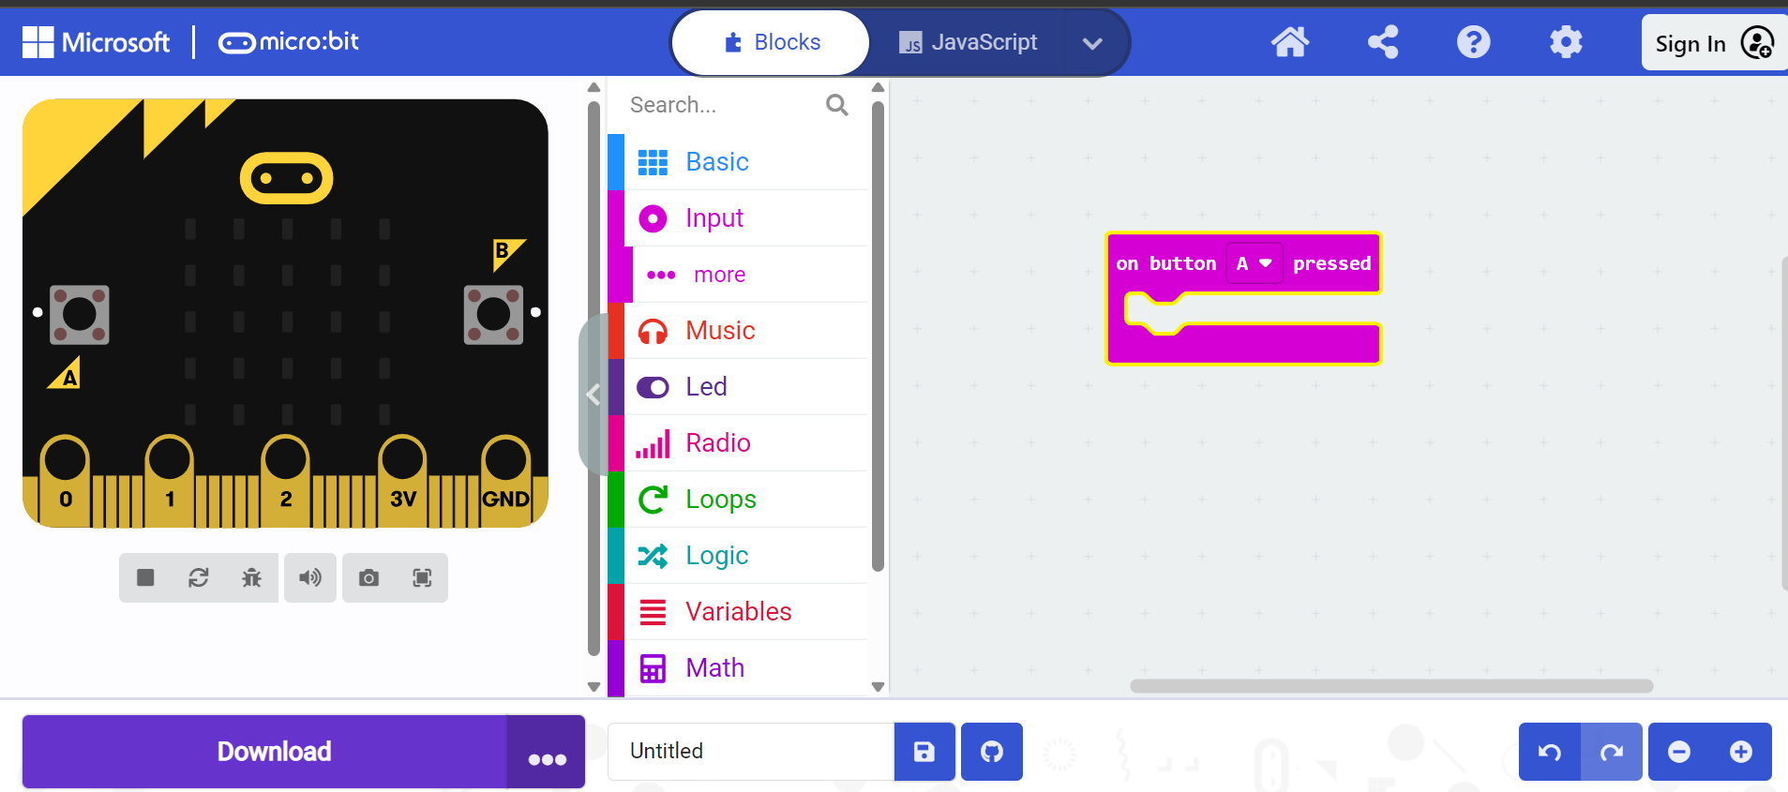

- Go to Basic and drag the block "show number" to your work field, place it in your other block:

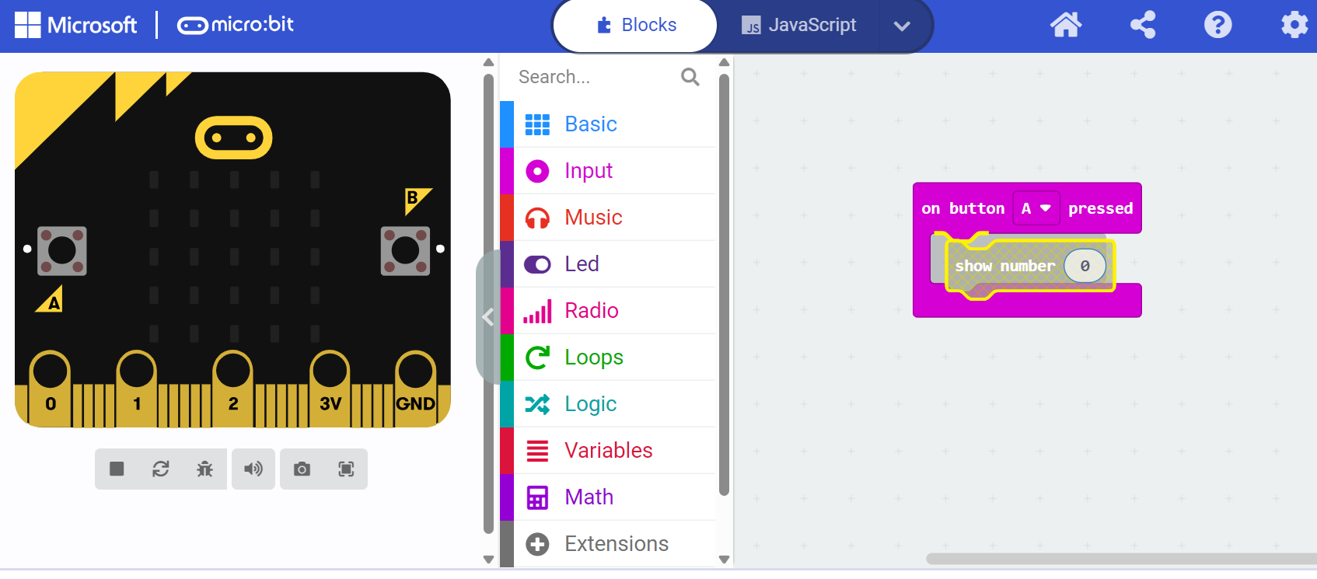

- Choose the number the Micro:bit should show for you:
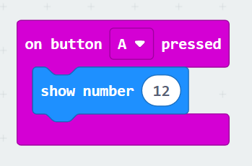
- Test your code on the Micro:bit example. If this is okay, you can download it.
Part B.
Now you are going to change the code so that when button A is pressed, not a number is shown but a letter. If you writing the correct code, show it to the teacher or TOA.

Assignment 3.3 Hot or cold?
Your Micro:bit has a built-in temperature sensor that we are going to use to measure the temperature of two different environments; the classroom and the fridge. Here's how we're going to do it:
1. Create a new project
2. Remove the base block "on start"
3. Go to basic and select "show number" and drag it to your work field:
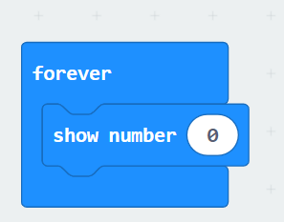
4. Go to input and select "temperature ( ͦC)" and drag it into your previous block:
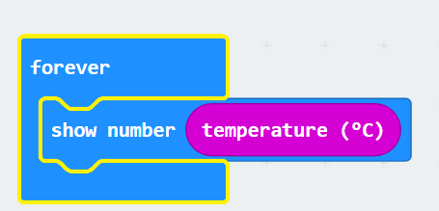
- In order to be able to follow the difference in temperature properly, we are going to enter a pause between measurements, we do this by choosing "pause (ms)". Place this block underneath your previous block. Set the pause to 2000 ms, so that every 2 seconds the temperature is displayed on the Micro:bit:
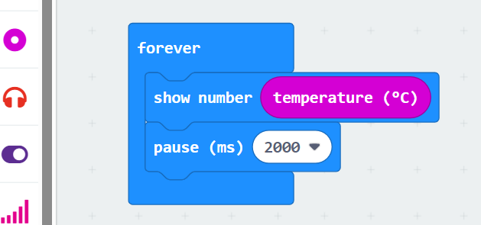
6.Repeat steps 3 and 4 to get the following screen:
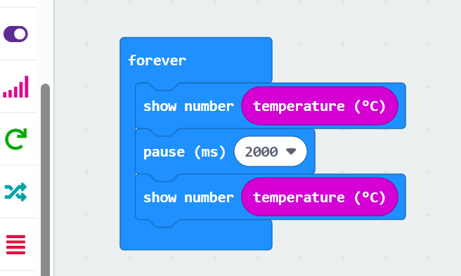
6. Place another pause block under the previous one, so that between the two loops there is also a 2 second pause.
7.In the Micro:bit example, you can see that the temperature is shown every 2 seconds. When you are finished, you can download the code on the Micro:bit. It showcases the temperature in the classroom. Now place the Micro:bit in the fridge and wait 5 minutes, what is the temperature?

Assignment 3.4 …..if, then…..?
Part A.
The Micro:bit allows you to program a logical code. We are going to do this by using the push buttons A and B.
1. Create a new project
2. Remove the base block "on start"
3. Go to logic and select "if true then else" and drag it to your work field, click it in the forever block:
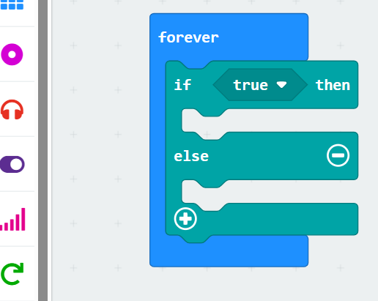
4. Go to input and select "button A is pressed” and place it in the true part of the if/else block:
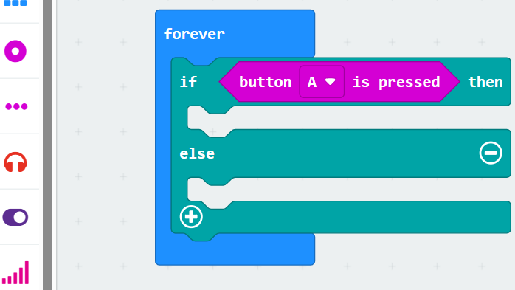
- Select in the basic “show leds” and place it between the if/else block and draw an A:
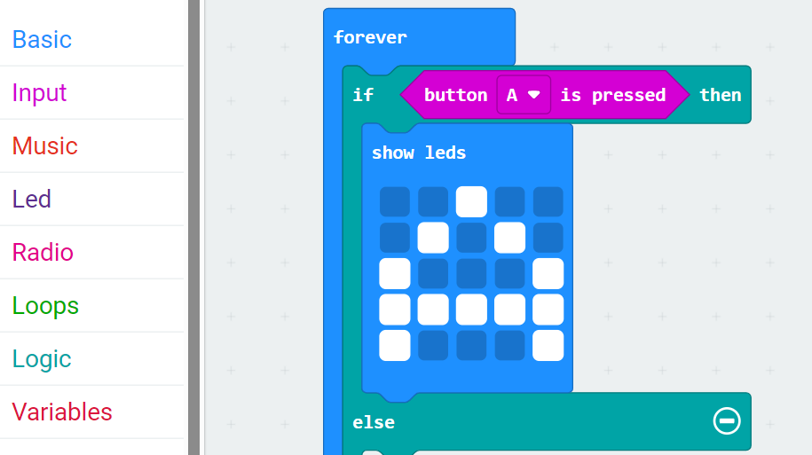
- Click on the plus sign and repeat steps 4 and 5 but change the A to a B:
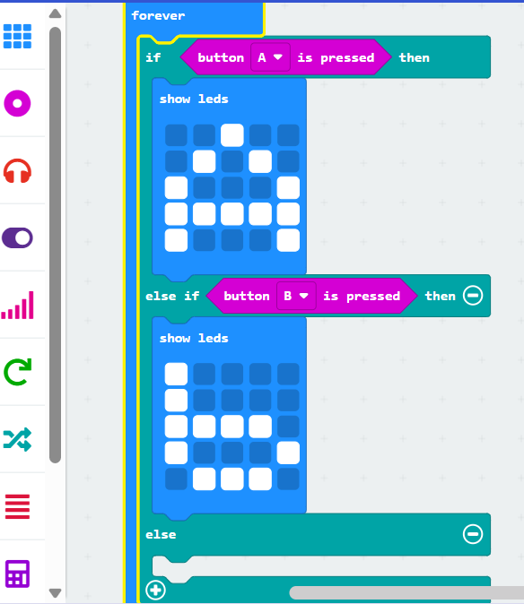
- Place a “show led” under the else and make sure that the Micro:bit shows a X when both buttons aren’t used:
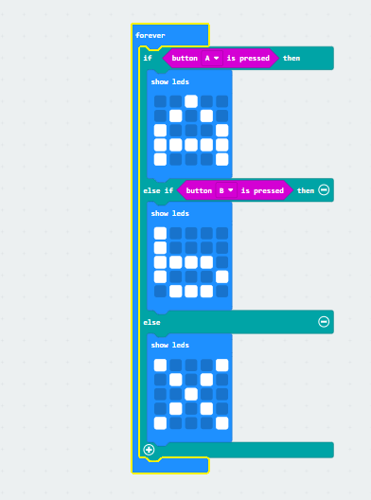
9. In the example Micro:bit you can now see that if you hold down button A, an A appears on the screen and a B appears when you hold down button B. If you do nothing, the Micro:bit shows an X. If you are okay with your code than you can download it on the Micro:bit.
Part B.
Now you are going to change the code so that when button A is pressed a number is displayed, for example 2 and when button B is pressed, a 4. When you are finished show it to the teacher or TOA.

Assignment 3.5 Which direction?
Part A.
As mentioned before, there is a built-in compass in the Micro:bit. We can apply the if/then function for this. Here's how:
1. Create a new project
2. Remove the basic block "on start"
3. Go to logic and select "if true then else" and drag it to your work field, click it in the forever block:
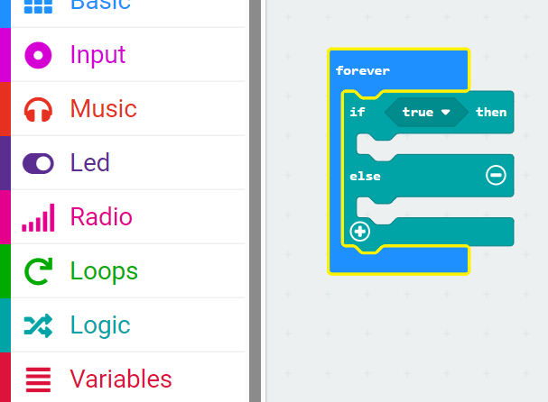
4. Select by logic under the heading comparison the "0 = 0 “ and place it in the true place:
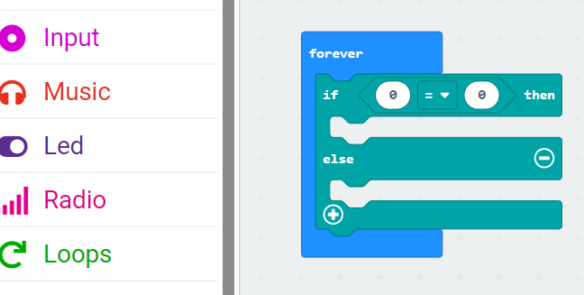
5. Go to input and select “compass heading” and place this in the first entry of the comparison “0=0”:
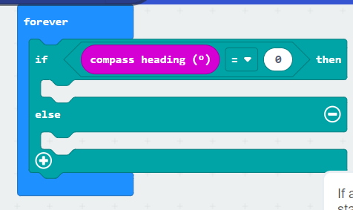
6. Now we are going to enter a value after the = sign, in this case we choose 45 degrees and add the block "show arrow north", (you can find this block in the basic section) under the first if value:
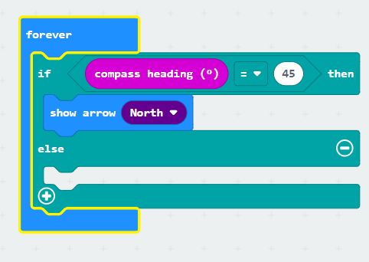
7. This ensures that when you hold the Micro:bit at a 45-degree angle, it shows an arrow pointing north.
Now we are going to code the other directions; east, south and west. This is done in a similar way. Repeat steps 5 and 6 for the east and south wind direction and choose 135 degrees for the east and 225 degrees for the south, adjust the = sign to a < sign and make sure your code looks the same as shown below:
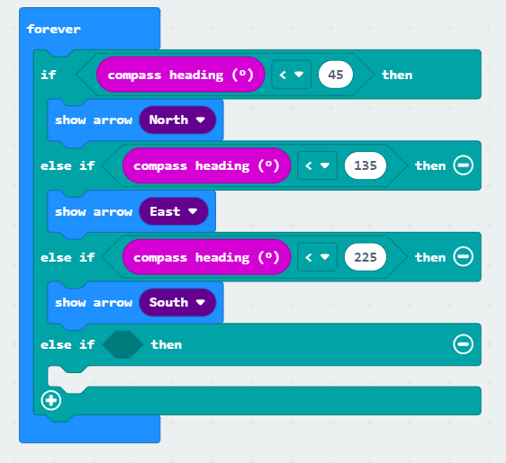
- As a last step we need to add the southerly wind direction, since we have programmed the Micro:bit to show arrows at the entered values (the if values) we can add the block "show arrow" west otherwise:
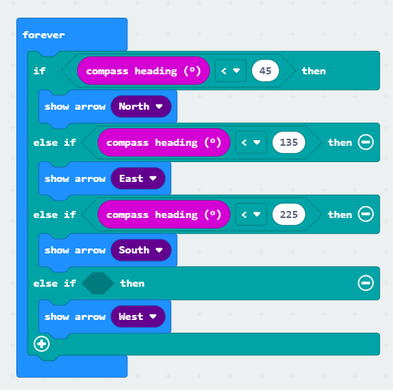
- In the example Micro:bit you can now see that if you change the compass direction the arrows also change. Happy with your code? Then you can download it on the Micro:bit.

- Once you have downloaded the code on the Micro:bit you have to calibrate it. You will see the text: TILT TO FILL SCREEN with a flashing led appear on the screen. Rotate your micro: bit in such a way that the entire screen is turned red (you will see that during the rotation more LEDs will turn on). Then the Micro:bit is calibrated and you are able to use the compass.
Part B.
We have now entered the standard wind directions, but we can expand our compass by adding the other wind directions; northeast, southeast, southwest and northwest. Expand your compass and choose the following values for northeast; 60, southeast; 180, southwest; 250 and northwest; 260. If you have succeeded in doing this, show this to the teacher or TOA.

Assignment 3.7 ….and the duck appears!
We can make two Micro:bits communicate with each other using the radio function. Here's how we can do this:
1. Create a new project
2. Go to radio and select "radio set group 1" and drag it to your work field, click it in the on start block:
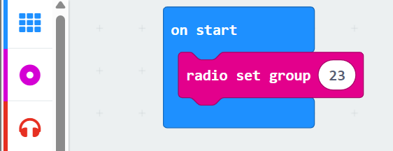
3. Change the number to 23. Go to input and select the “on shake” block:
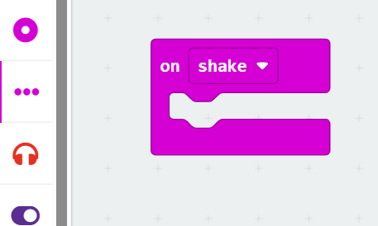
4. Add the block "clear screen" (to be found at basic) to the block on shake, then add the "radio send string" " " block. This block can be found under radio. In this case, we're going to send a duck over the radio, so we're going to type the word duck:
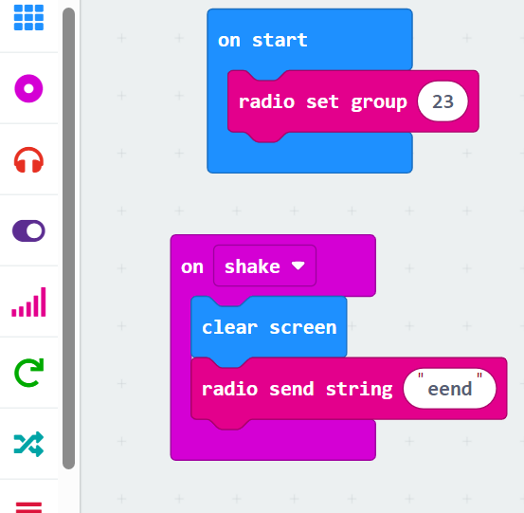
5. Now we need to add the icon of a duck; go to basic and add the “show icon” block to the work field. Go to radio and add the block “on radio received receivedString” block. Add the two together:
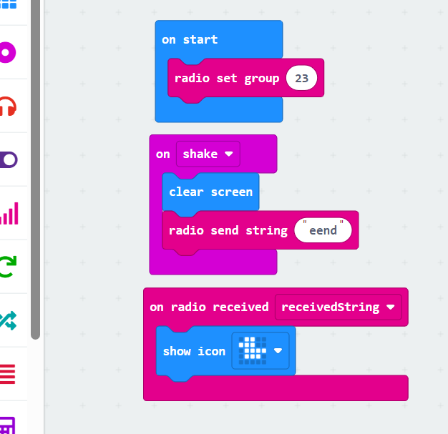
6.In the example Micro:bit you can now see that when the micro: Bit is shaken, a duck appears on the screen. Once you're happy with your code, you can download it.
7.Now shake your micro: bits and see what happens!
Part B.
We can change the code in such a way that when we have pressed a button, the duck is not sent. Adjust the code so that when the person who has the duck on the screen and is pressing button A, the duck is not sent. If you have succeeded in this, show it to the teacher or TOA.

Assignment 3.7 Rock, paper, scissors!
With the Micro:bit we can also play games; such as rock, paper and scissors. We do this with the help of radio and the use of a variable. Here's how to do it:
- Create a new project

- Go to input and select "on shake” and drag it to your canvas. After that, go to variables and click on "make a Variable...." and name it hand
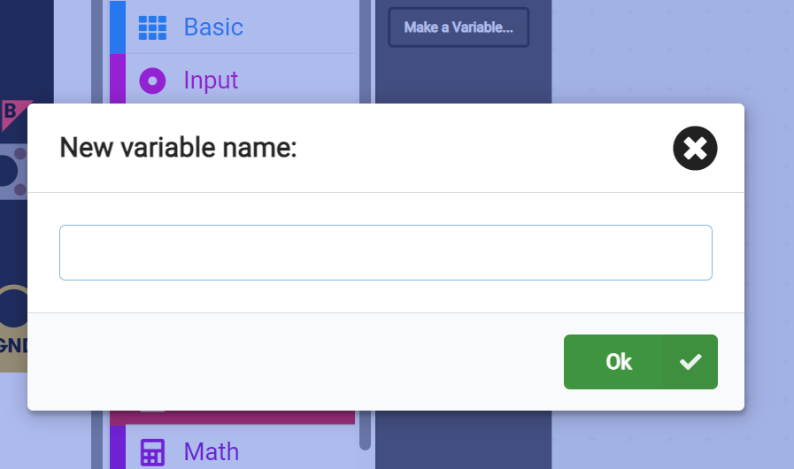
- There are now two options, we are going to use "set hand to 0". Drag it to your workspace and click it into the on shake block:
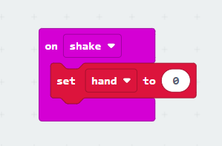
- Since we have 3 different options for rock, paper and scissors, we go to the math input and choose the block "pick random 0 to 10", Place it in the set hand to 0 block and change the values from 1 to 3:

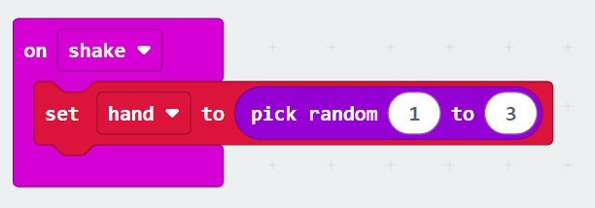

- Now, in Logic, we're going to use the "if true then else" block, drag it to your workspace and place it under your already written code:
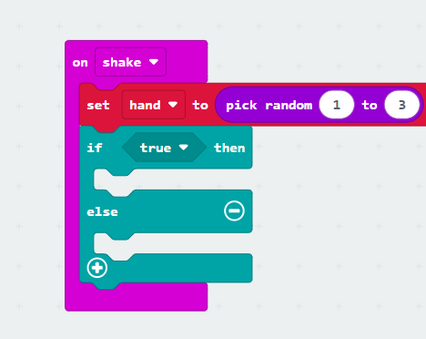
- Now we are going to use the "0 = 0" under the heading math and put it in the true place as you did for assignment 3.6:

- Click on the plus sign and repeat the above step:
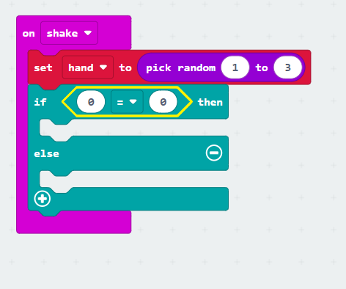

- Now we're going to change the code, just like you did in assignments 3.5 and 3.6. The difference in this assignment is that we have to use the variable "hand". We place this in the first value, as shown below:

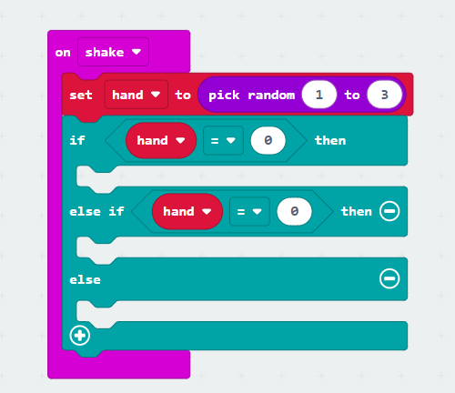
- The only thing left to do now is to indicate that when hand is equal to 1, a paper appears, with 2 a stone appears, otherwise scissors appear. We do this by adjusting the values in our "if/then" and using the "show led" blocks from the basic to draw the symbols. Once you've done all of this, you'll see the following code:
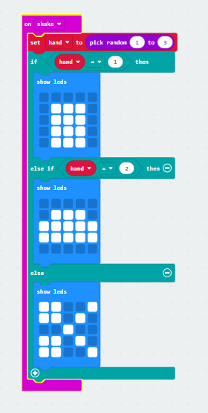
10 .In the example Micro:bit you can now see that when the micro: Bit is shaken, one of the symbols of the game appears on the screen.
11.Although the code is now almost ready, we are going to use the radio function to allow the Micro:bits to communicate with each other. We are going to use the basic blocks forever and the on start. Add the “radio set group 1" (you can find this at radio) to the block at on start:
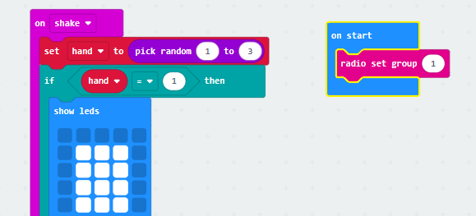
- Drag the whole if/then block into the "forever" block, make sure you leave the "set hand...." in the on shake cube:
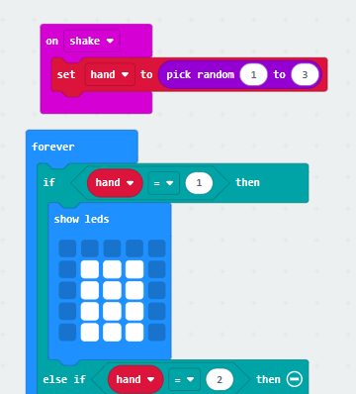
- Add the Radio function "radio send number 0" to the forever block and change the value to the variable "hand":
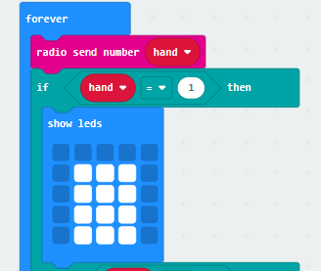
14. The last step is to add one of the basic "clear screen" blocks to the on shake block:
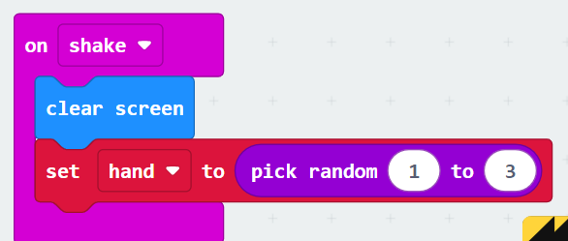
15.Once you've got everything ready, your code will look like this:
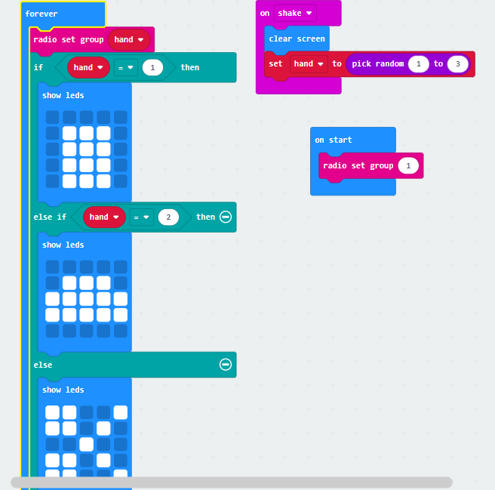
Once you're happy with your code, you can download it. Now you can start playing, who won?

Assignment 3.8 Ultrasonic sensor
In addition to the built-in sensors, we can also use external sensors such as an ultrasonic sensor. With this we will determine the distance.
Part A.
1. Create a new project
2. Go to variables and click on "new variable name:" give it the name display:
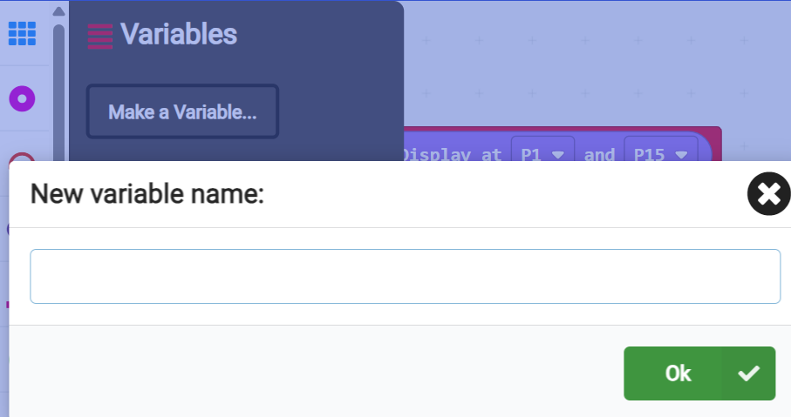
3. Go back to variables and place a "set display to 0" and place it in the "on start" block:
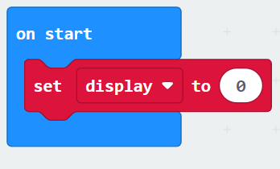
4. After that, go to your toolbox and click on extensions and choose Grove:
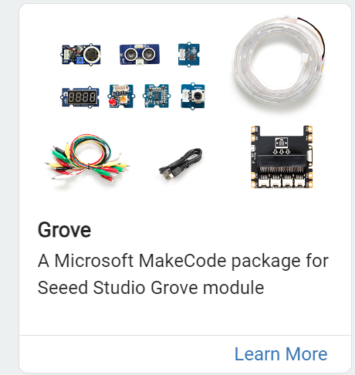
- You will now see a new tool appear called Grove, recognizable by the three blocks:
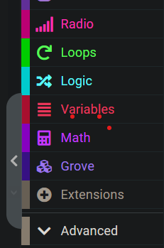
- Click on grove and choose the block "set 4Digit to 4-digit display at P0 and P0" and place it under the variable block. Change the 1st P0 to P1 and change the 2nd P0 to P15:
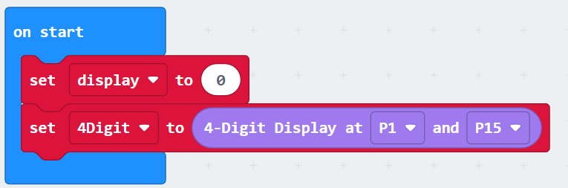
- In your toolbox, click on advanced and choose "serial" (recognizable by the USB sign). Choose the block "serial redirect to TX P0 RX P1 at baud rate 115200" and place it under the above mentioned:
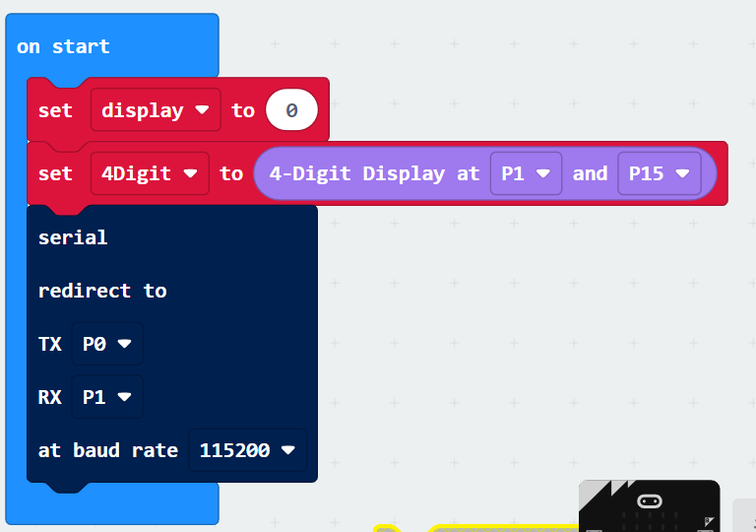

- Change the TX value to USB_TX, the RX value to USB_RX and the baud rate to 9600 (this is where the micro: bits communicate):
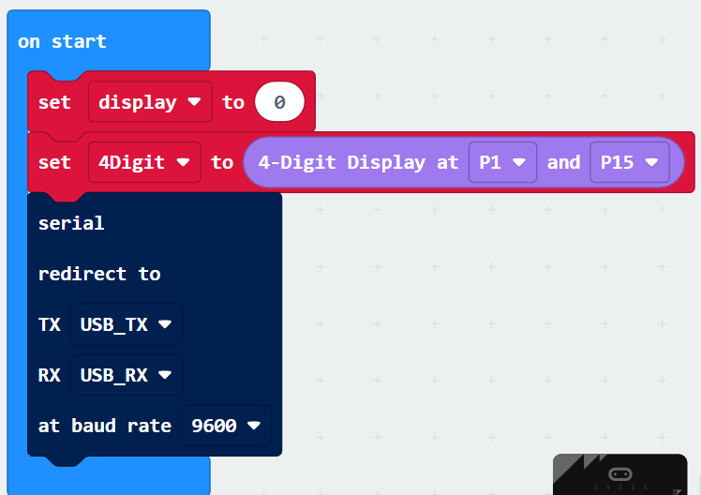
- In the "forever" block from serial, place the "serial write value X = 0". Change the X value to
" " (by deleting X) and select from grove the block "ultrasonic sensor (in cm) at P0" and place it in the 0 value:
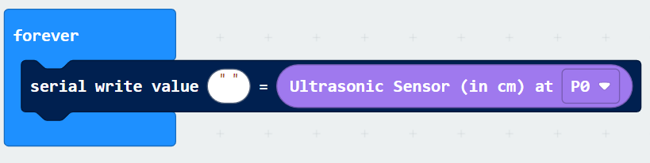

- Go to basic and place a "pause (ms)" block under the serial block. Set the time to 1 second:

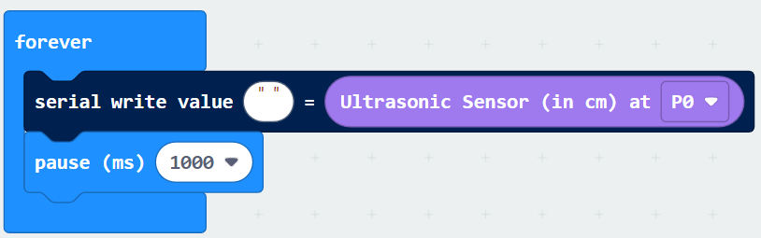

- Now that the code has been written, we are going to connect the Micro:bit to the groove shield. Since we used the P1/P15 ports, we're going to use this port to connect the ultrasonic sensor to the groove shield. Then place the Micro:bit in the groove shield: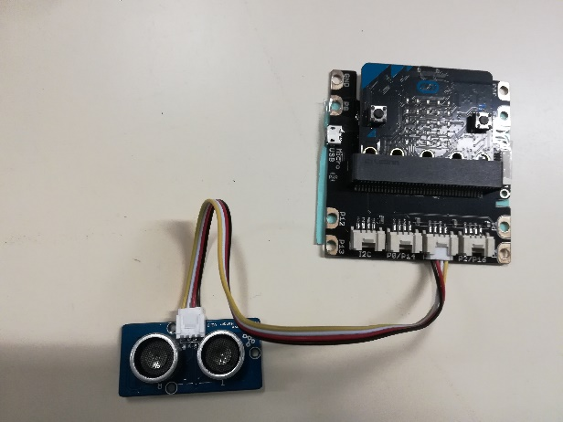 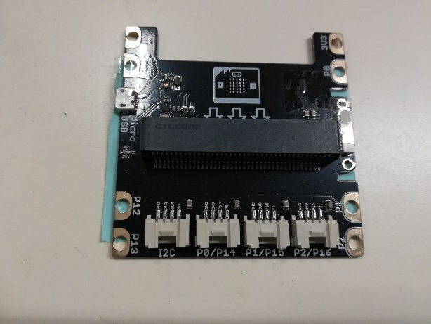

- To measure the distance with the micro: bit, you have to connect it to Excel on your laptop. You can find out exactly how to do this in 3.8.1 Preparation Excel.
- Once you have completed these steps, your partner will be able to move a big item, like a book at different distances from the Micro:bit and you will see that the distances are displayed in Excel.
Part B.
Now we are going to determine the accuracy of the Micro:bit by moving different sized items. What do you notice about the accuracy of the micro: bit?

3.8.1. Preparation Excel

  - Open an empty worksheet in Excel and see if you can find Data Streamer at the top of the menu bar:
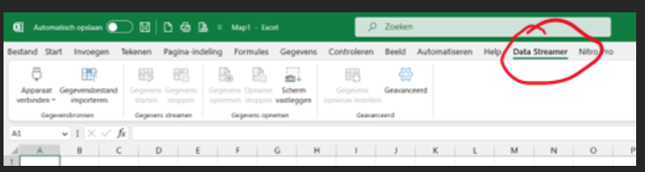
If not, you'll need to add it. Go to Excel, file and at the very bottom to options:
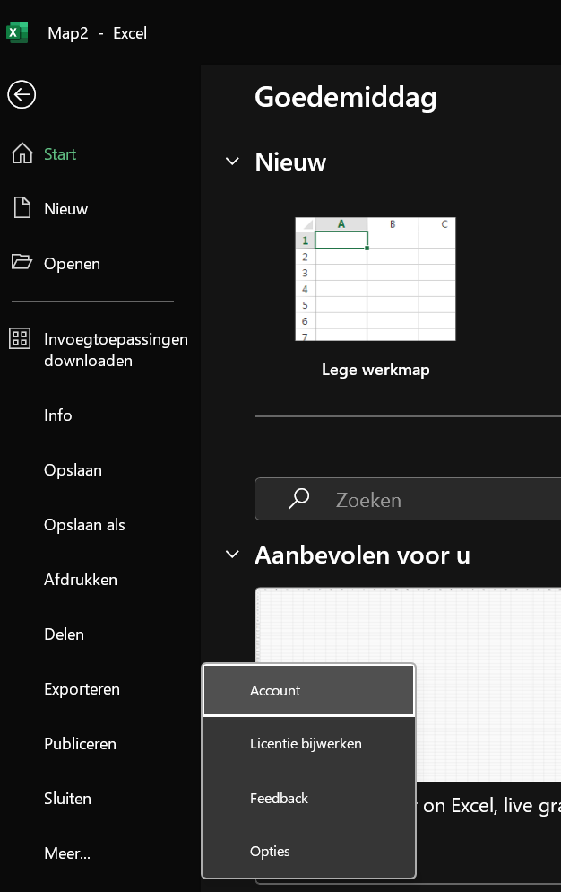
  - Then choose the add-ins option and change the option Excel add-ins to COM applications at the very bottom of the administration:
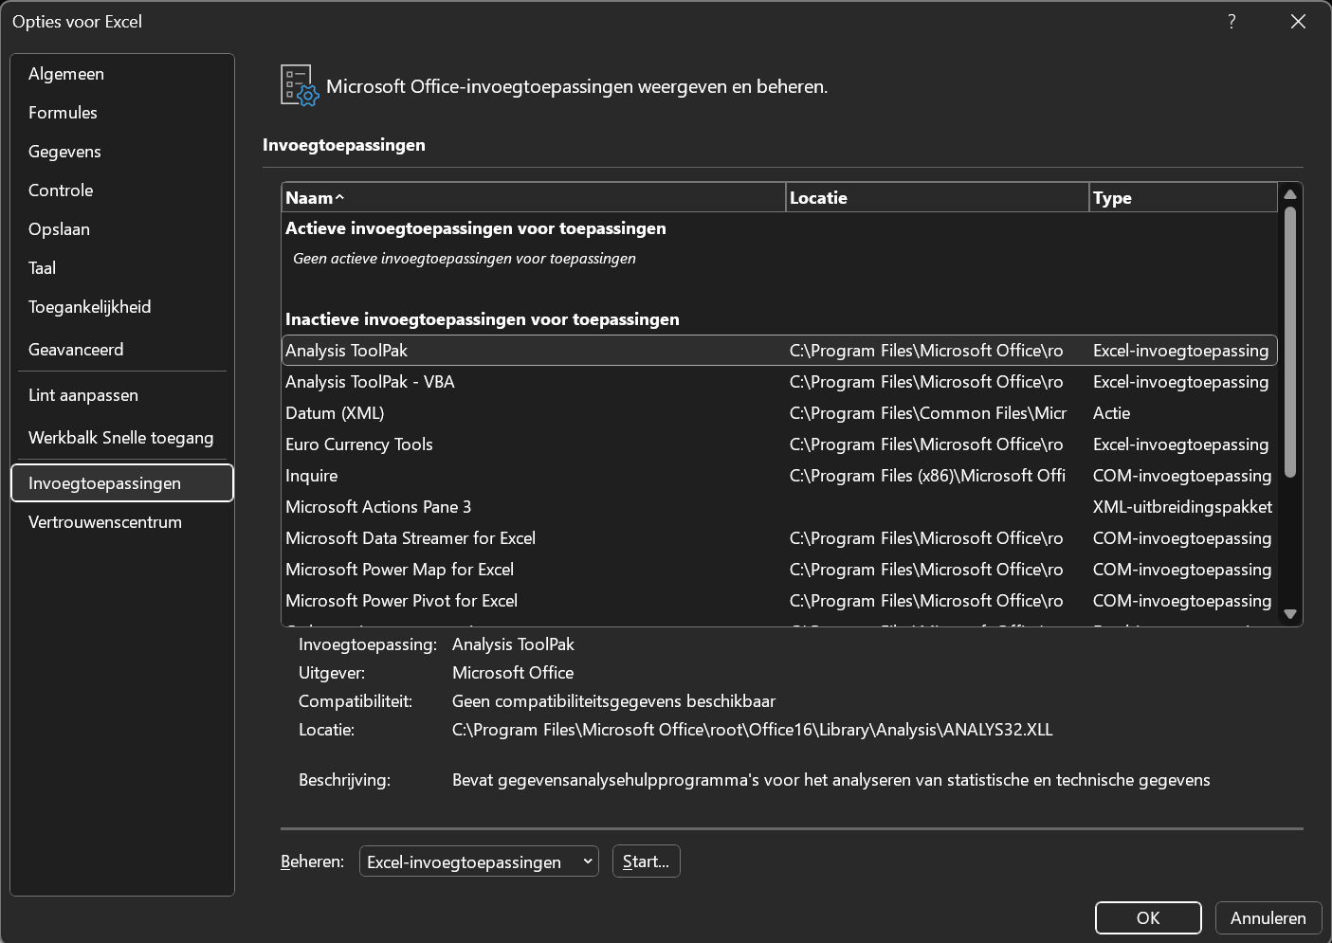
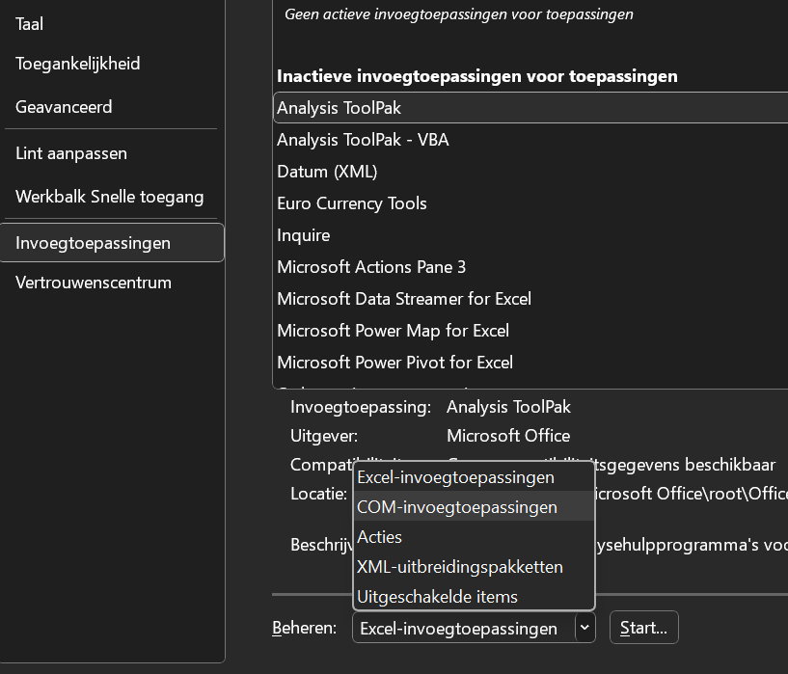
  - Click on start and a pop-up should appear where you can choose “Microsoft Data Streamer for Excel “ and continue with clicking op OK
  - DataStreamer should now be visible in Excel

3.8.2 Application Micro:bit and Excel
- Now that everything is prepared, we can start the measurement. Connect the Micro:bit to your laptop. Go to Excel and check if your Micro:bit is connect via the "Connect Device" button:
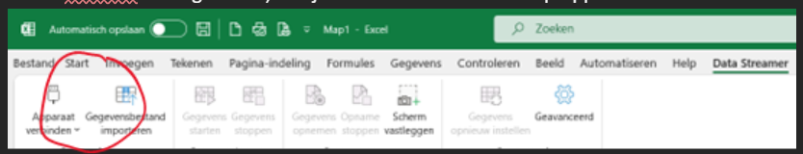
- After that, choose the option Serial USB Device COM#, to which the USB port is connected
- The "baud rate" with which it communicates is 9600, which is why the Micro:bit is set this way. Once the connection is made, a measurement screen is automatically created:
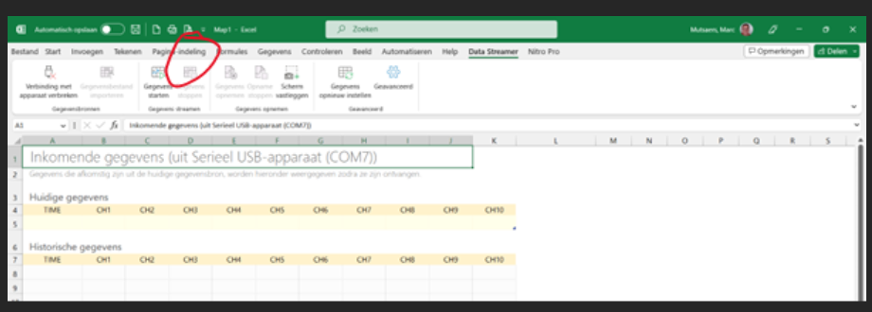
- By clicking on the "start data" button, the measurement data of the connected Micro:bit will be displayed. It can also be recorded by clicking on the Record Data button. Once "Stop Recording" is pressed, the measurement data is automatically saved and prompts for a name, location, and file name. This file is then suitable for editing for a graph.

Tip! If there are no numbers visible or you see XXXXXXXX in the table than widen the table=

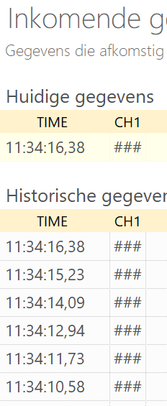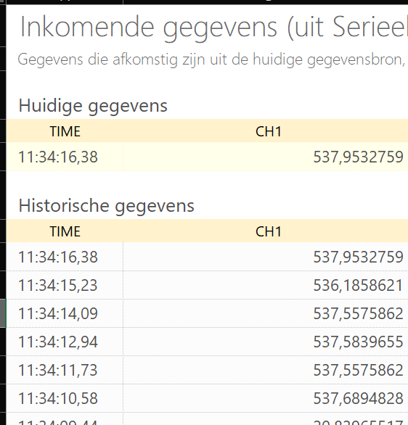

1. Turn the data into a graph. This is done in the same way as you are used to from Excel. If you don't know this, below is a description of how to do this. If you do know this, you can continue with PART B of this assignment (page 32).

- Go to Excel, to tab Insert and click on the scatter chart and choose the first option, as shown below:
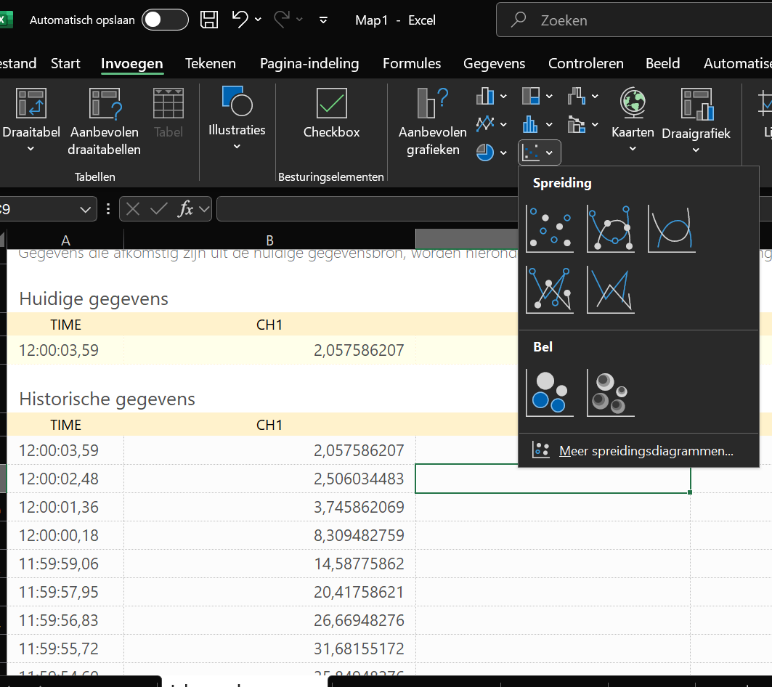
- You will see a white area in which you van plot the graph. Right-click in the white area and click Select data:
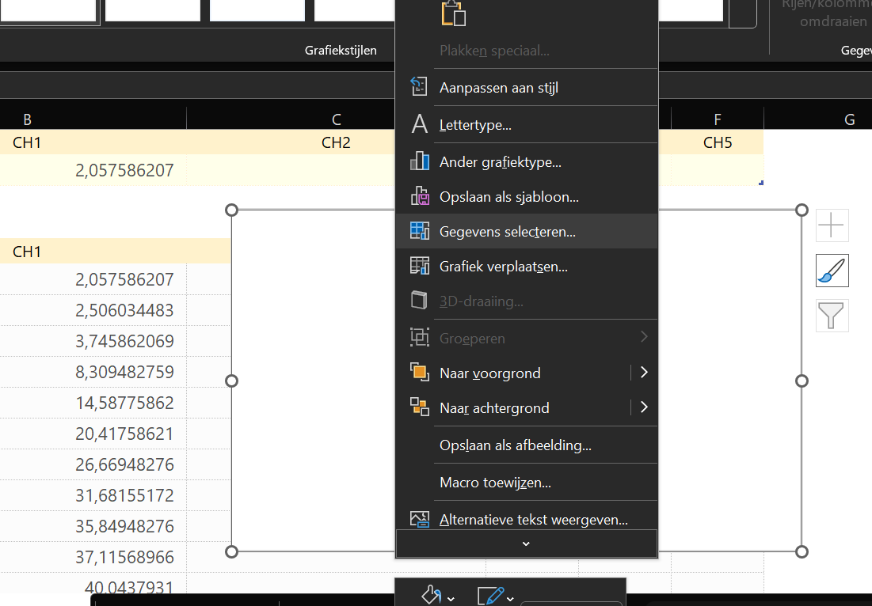
- Again you will get a pop-up with the options to add a new series, we will do this by clicking on add:
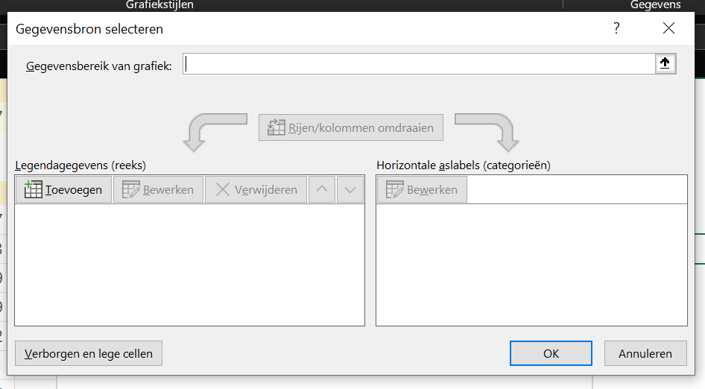
- There will be a small screen in which you can select the X and Y values:
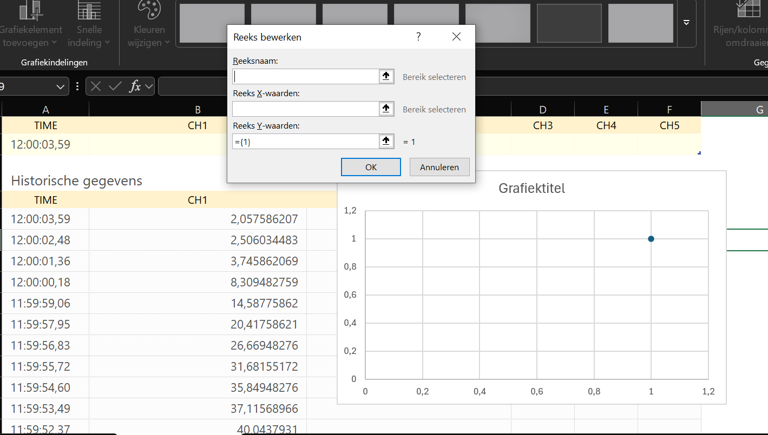

- Select for the X values the time and de height fort he Y values. Click on OK:

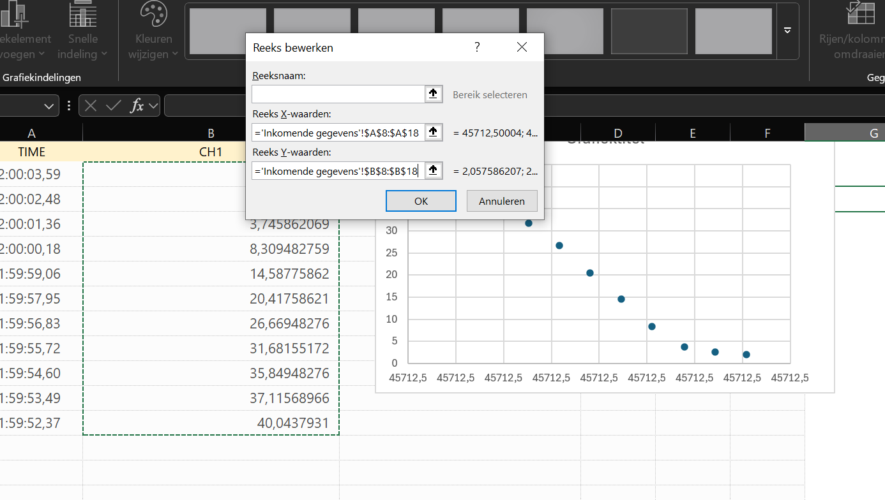

- As you can see, a graph is plotted. Then press OK and you can start formatting the graph with a nice title, axis titles and a legend. Do this by clicking on the + sign next to the graph and checking the different parts you want to display:
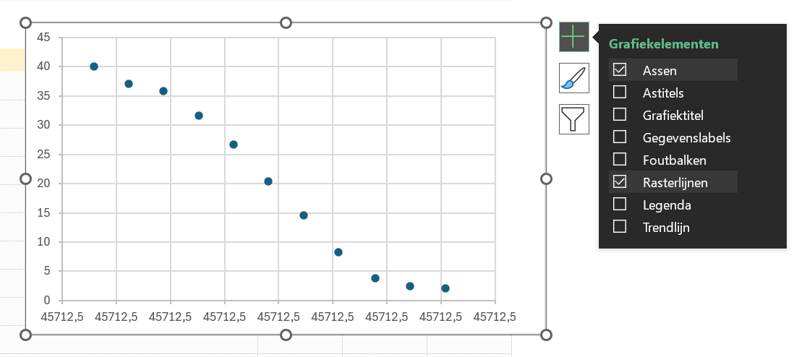

- Once you have selected and adjusted everything, it may look something like the one shown below:
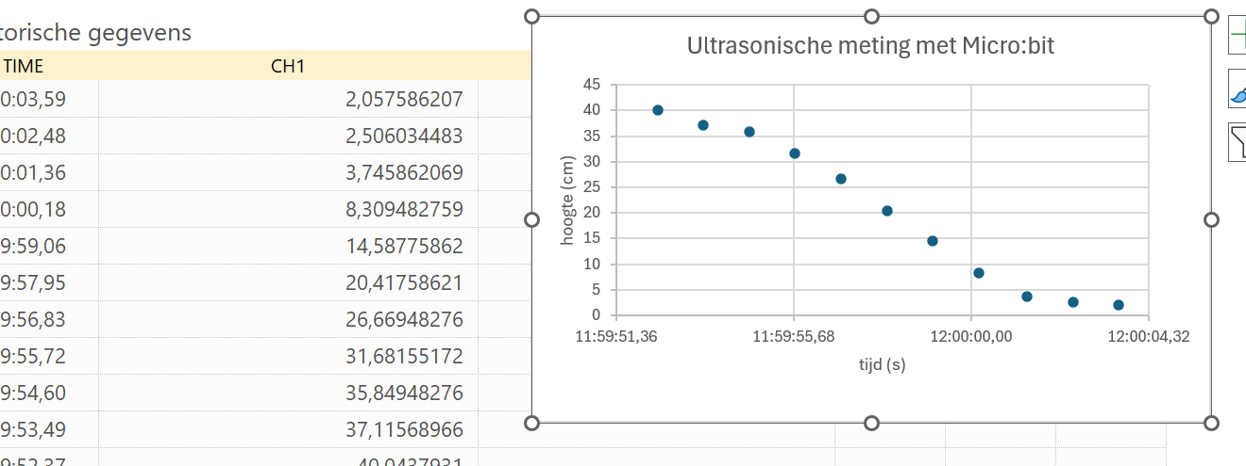

Projects
Now that you're familiar with the Micro:bits, let's expand the codes a bit. The codes will be longer and we will use external sensors.

4.1 Follow the line!
As mentioned above, we are going to use an external source, in this case the Maqueen Plus set. This will allow us to build a robot, which we will program in such a way that it will drive in a circle. To do this, follow these steps:
- The TOA/teacher will give you a Maqueen Plus suitcase containing the kit of the robot. The case contains a manual in which you can read exactly how to assemble the robot. You will also receive a battery from us, which the robot needs to move around:

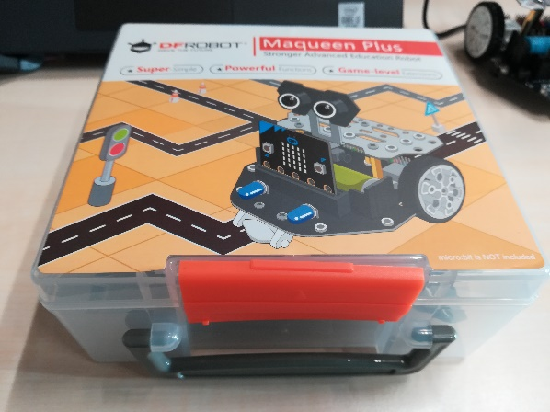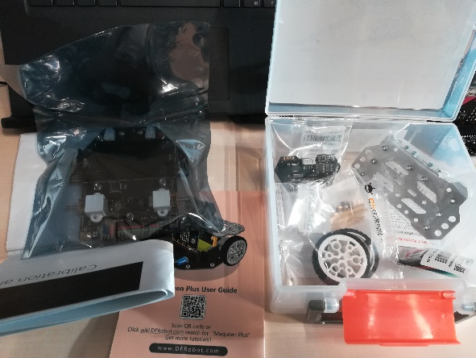
- If you have followed all the instructions correctly, you will see the following robot:
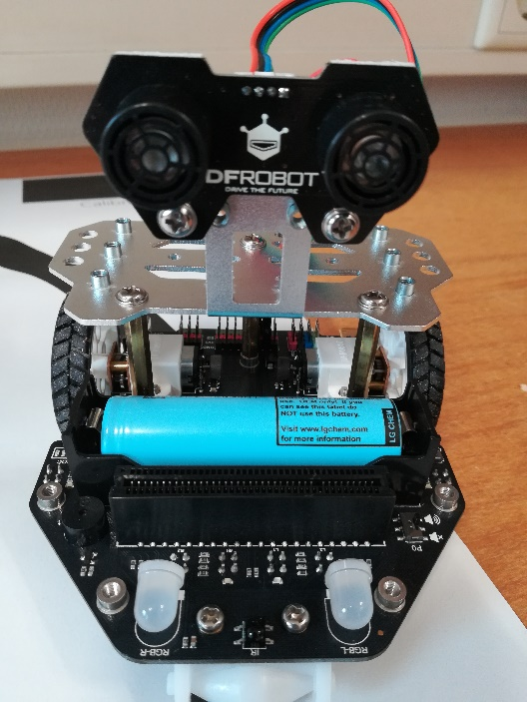
- Now that the robot is assembled, we can start writing the code. Create a new project

- Choose the "forever" block and remove the "on start" block

- Go to Logic and choose the "if true then" block and place it in the block above:
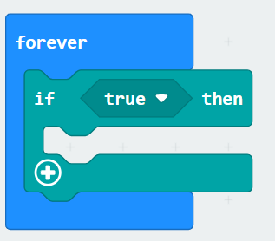
- In your Toolbar, click on "extensions" and choose MaqueenPlus, click on it and you will see that it has now appeared in your toolbar:
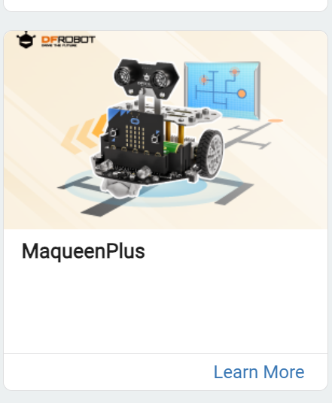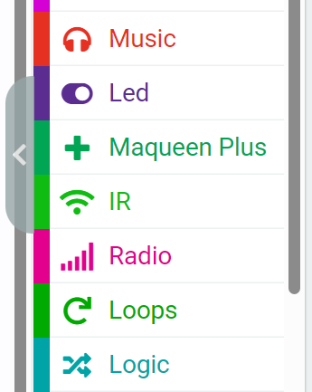

- Go to Logic and under the Boolean value choose "....and....." block and place this in the "true" value of the logic block:
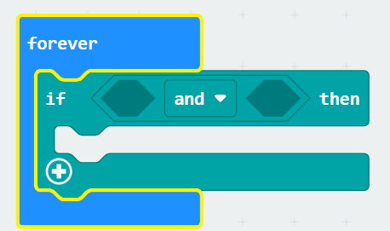
- Then go back to logic and choose the "0 = 0" block under the heading comparison, place it 2x in the open boxes of your previous block:

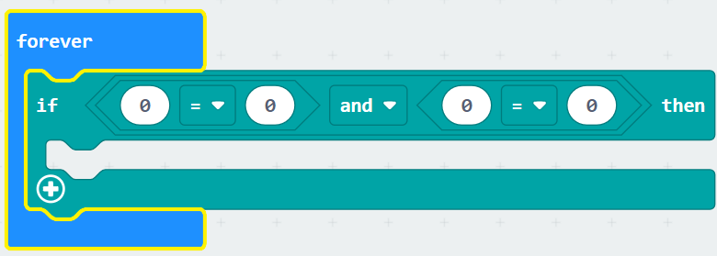

- Set the last two values to 1 and then go to the new MaqueenPlus and choose the block "read line-tracking sensor L1" and place it 2x in the first values. Now we need to rogram the robot to use the sensors just below the front wheel to follow the black circular line. We have to set the last sensor to R1, for the right side:
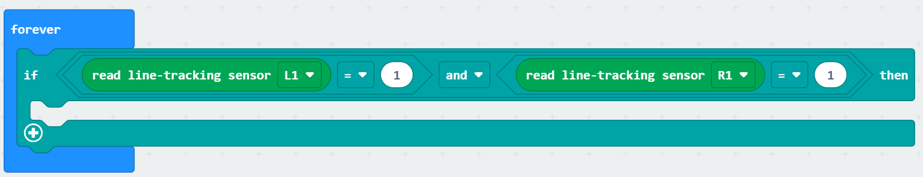
- Go to MaqueenPlus again and choose the block "motor left direction rotate forward speed 0" and place it in the logic block. Set the speedvalue of to 60. Also set the engine to ALL:
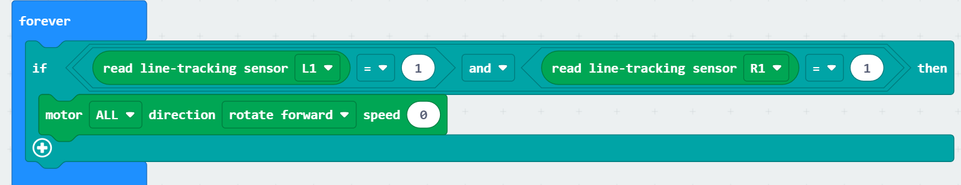
- Click on the plus sign and then copy the set logic block and place it in the other piece:
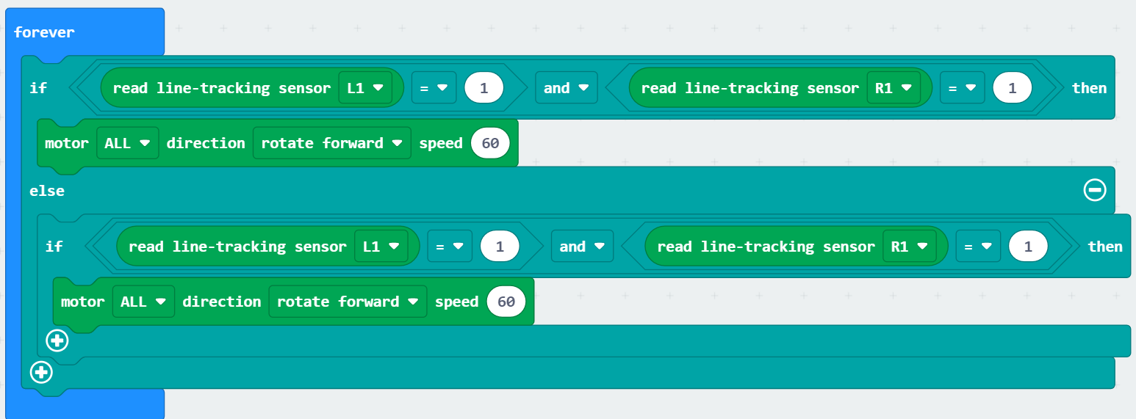

- Now we are going to change the values of the copied block. Set the L1 value to 0, change the motor direction to left and change the speed to 160. After this, place another "Motor lift direction rotate forward speed 0" under the first one and set it so that your right motor has a speed of 30:
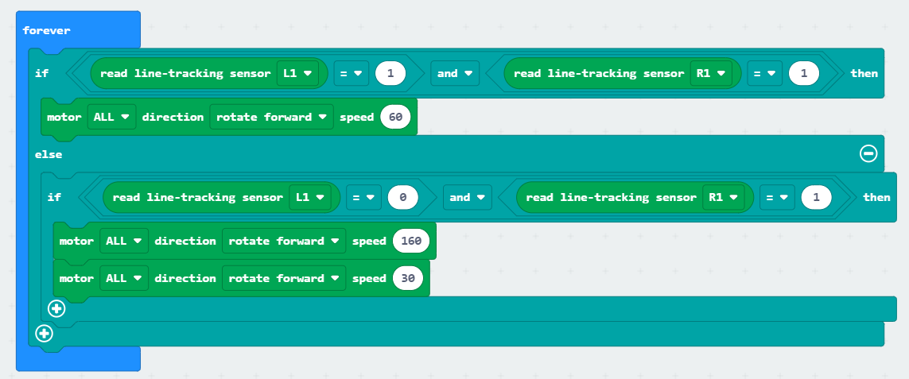
- Click on the plus and copy the block we just made and place it under the previous block. Change L1 value to 1 and the L2 value to 0. Change the motor speed on the left to 30 and the speed on the right to 160:
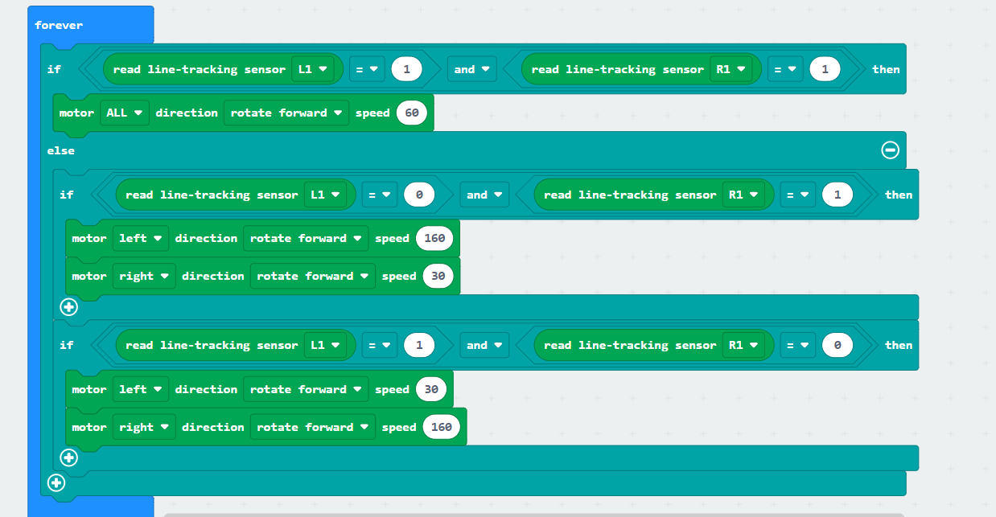
- Now we have finished our code. If you are satisfied you can download it. Now insert the Micro:bit into the MaqueenPlus robot:
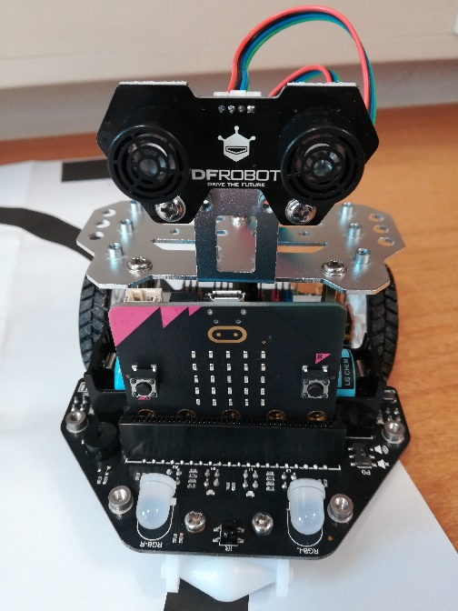
- Unfold the poster with the circle on the floor or table and place the robot on the line. There is an on/off button at the back right:
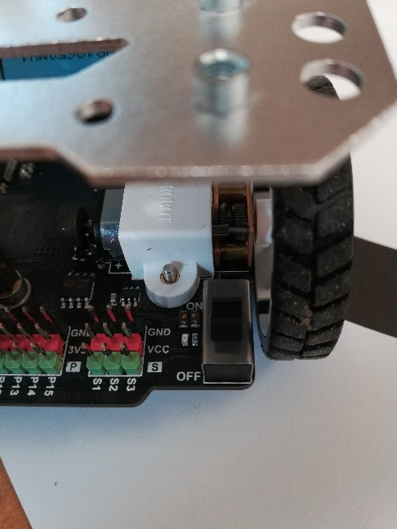
- Turn it on and see what happens!

4.2. Space invaders
We can also develop a more complicated game than rock, paper and scissors, such as the famous arcade game Space Invaders. The Micro:bit is ideal for this. When coding this game, we are going to discover two new input blocks; Loops & Game.
- Create a new project
- Create a variable and name it "ship". Insert the block "set ship to" into the basic block "on start"
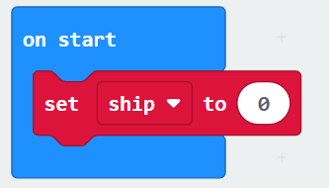
- Go all the way down to your tools and click open the advanced menu, you will see a controller icon in green, this is the Game input block.
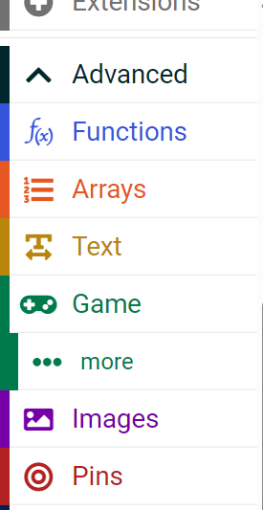

- Choose the first block "create sprite at x: 2 y:2" and place it in the value of your variable block. Change the y value to 4:
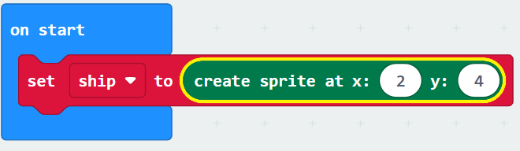

- Place the "set score" (from the game tools) and place it under the previous block:
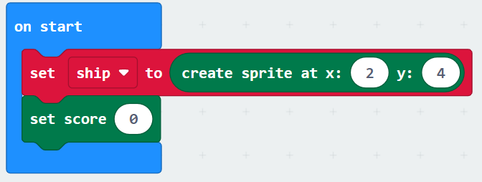
- Go to input and choose the block "on button A pressed" and drag it to your work field. After that, go to game, choose the block "ship move by 1" and place it in the block. Make sure you set the value to -1 because you want to move the spaceship to the left when you press button A:
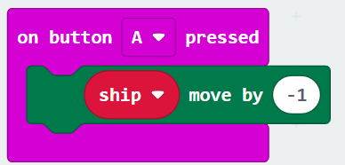
- Copy the above block but change button A to button B and change the value to 1 because by pressing button B you want to move the spaceship to the right:
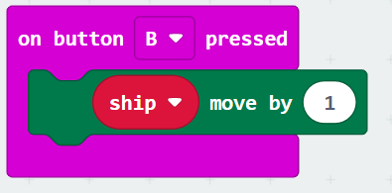
- Now we're going to use the "forever" block. Go to variable and create a new variable called; "enemy". Place the block "set enemy to" in the basic block "forever". Then go to game and choose the block "create sprite on x2: Y:0" and place it in the value of the variable block:
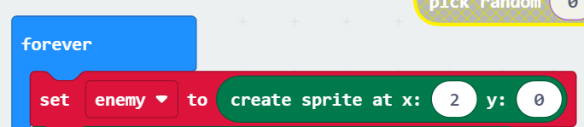
- Go to math and choose the block "pick random 0 to 4" and set it to the x value. Go to game and choose the block "enemy change x by 1" and place it under the variable block. Change the vx to brightness and the value to 150:
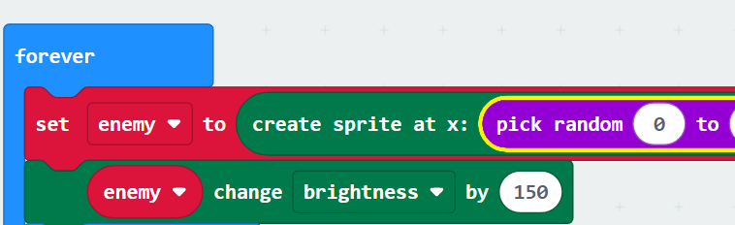
- Go to basic and choose the block "pause ms" and place it underneath. Then go to game and choose the block "enemy turn to the right with ( ͦ)" and place it under the pause block. Set the value to 90:
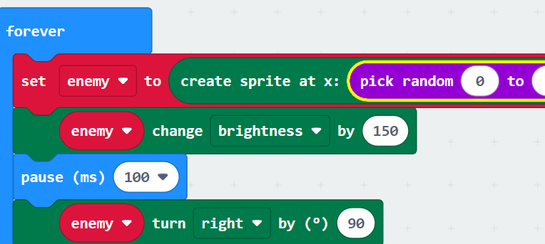

- Now we're going to use the second new tool, the Loops. Go to your tools bar, to Loops and choose the block "repeat 4 times" place below your code. Then go to game and place the block "enemy moved by 1" in the loop. Place a pause block below and set it to 500 ms:
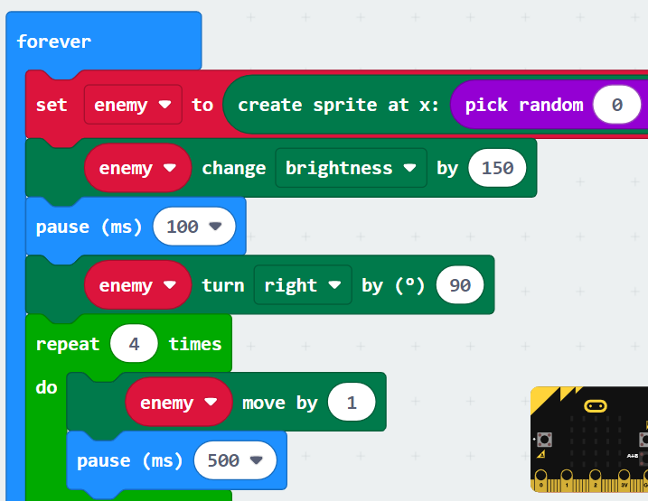

- In the last steps, we will use the logic "if where then" blocks. Place 2 of these blocks underneath each other under the loop block:
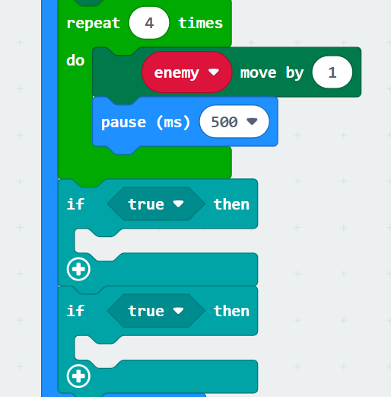
- Change the true value in the "is sprite touching ?" block (from the game). Change the setting so that if the "enemy" hits the "ship", the game is over. You can find the block "game over" in the game:
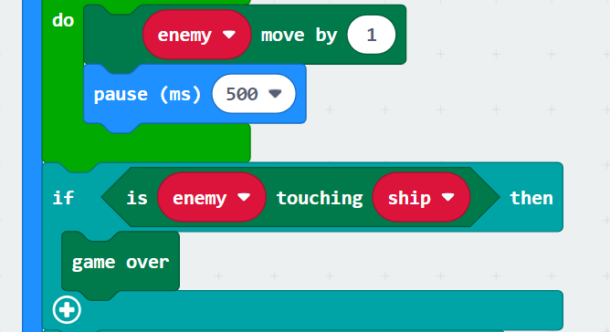

- We are going to fill in the last if then block as follows; choose "is ....touching edge" (by game) and place it in the value. Place the "game over" in the if/then block. Don’t forget to change the value to the variable "enemy":
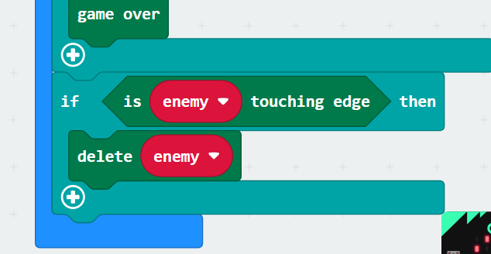
- Now you can already see a few things about the game in the Micro:bit example. You can already move the spaceship, but now you have to be able to shoot with the spaceship. We are going to do this by pressing both push buttons. Go to input and choose the block "when button A is pressed" and change the value to A+B. After that, go to variable and create a new variable called "shoot". Place "set shoot in" in the pink cube:
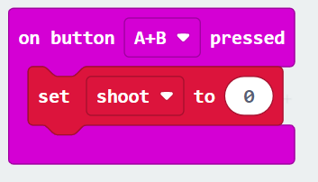

- Change the shoot value to "create sprite at x:2 y:2", which can be found at game. Then add the "sprite x" to both the x value and the y value. Change sprite to "ship":
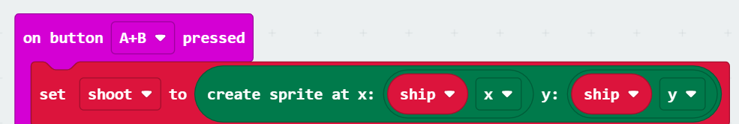
- Go to game and choose the "sprite change x with 1" block. Place it under the variable block. Change the X to brightness, the value to 80 and the sprite to shoot:
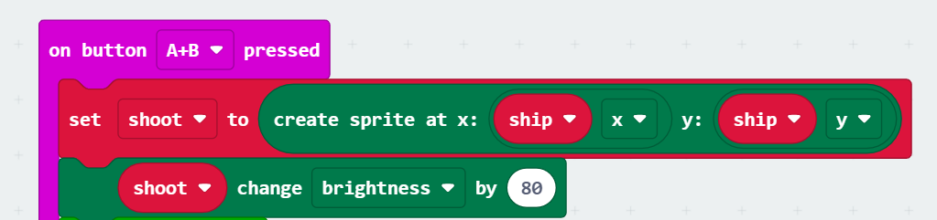
18. Now place the block "repeat 4 times" from loops and place it underneath. Then go to game and place another cube "sprite change x by 1". For this block, change the sprite to shoot, the x to y and the value to -1:
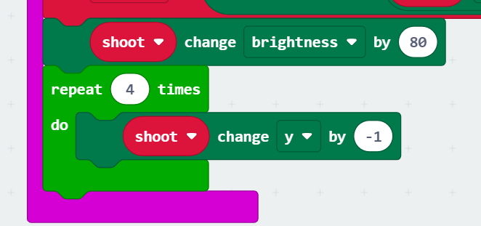
- Go to basic and place the "pause ms" block and set the value to 150. Then we add a "if true then" block from logicl:
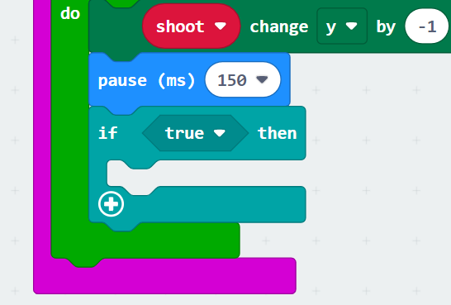
- Change the true value to a block "is sprite touching" (from game). Code it that the "shoot" hits the "enemy". In the logic block, add the block "change score by 1":
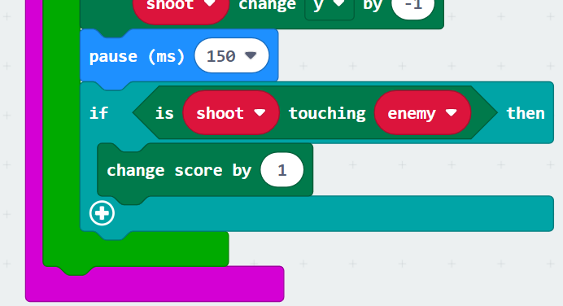
- Then add 2x a "delete this" block which you can find at game. Change the first value to “shoot” and the second value to “enemy”:
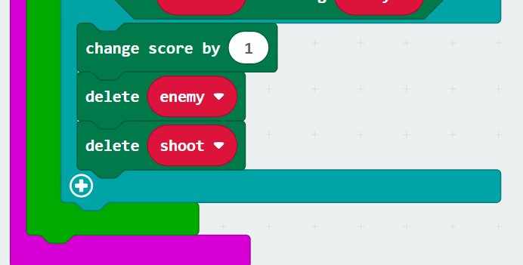
22. The last step consists of adding another "delete this" block, but this time after the loop block. The value must be changed to “shoot”:
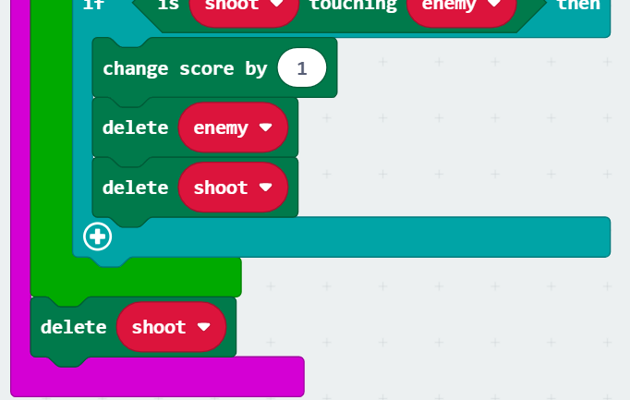
23. Now you can see in the Micro:bit example that the game works, but the best thing is of course to run it on the Micro:bit itself. So, if you're happy with your code, you can download it. How high is your score?

4.3 Micro:bit and Excel
We can connect external sensors to the Micro:bit, but we can also have the minicomputer communicate with Excel. To do this, we need to write two types of code and also use two Micro:bits. Furthermore, we are going to use the internal thermometer of the Micro:bit to measure the temperature in a certain room and transmit it to another Micro:bit.

4.3.1 First code (Radio transmittor)
1.Create a new project, leave both basic blocks, we're going to use them both
- Go to Basic and choose "show icon" and place it in the startup block:
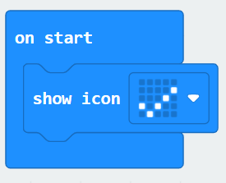
- Go to Radio and choose the block "set radio group" and set it to 69:
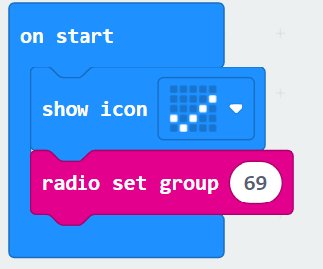
- Place the following basic blocks in the basic block "forever” ; "Clear Screen" and "Show Icon" (2x), as shown below:
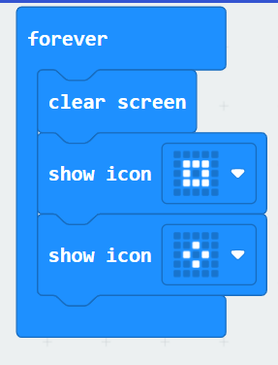
- Create a variable and name it "Sensor data". After that, place a "set sensor data to" between the two "show icon" blocks. By input choose “temperature” and place it in the value behind sensor data:
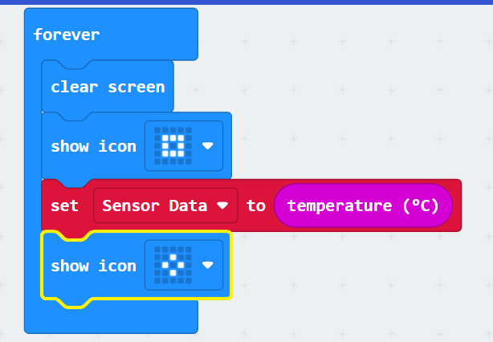
- Go to Radio and place a "radio send number" under the variable block. The radio has to transmit the sensor data, so we change the value to the variable "sensor data":
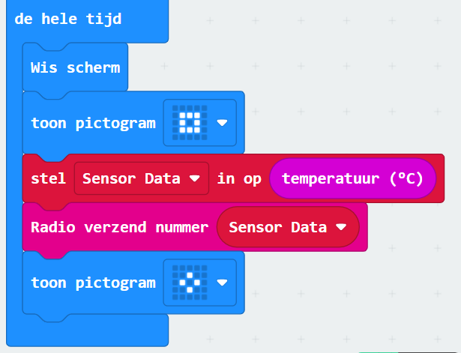
- Are you satisfied with the code? Then you can download it on the 1st Micro:bit. Now choose an environment to measure the temperature, for example a refrigerator, or on a windowsill (on a warm sunny day), the choice is yours!

4.3.2. Second code (radio receiver )
The second Micro:bit is the receiver, which will display the received data in Excel. We will use the input block; Serial.
- Create a new project, leave the baiss cubes, we need both.
- Go to radio and choose the block "set radio group" and set it to 69:
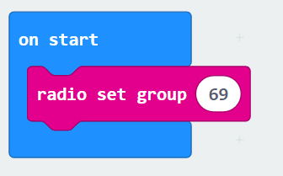
- Go to serial and choose the block “serial redicrect to TX P0 RX P1 op baud rate 115200” and place it in the on start block:
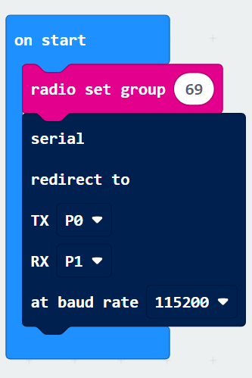
- We're going to use the USB port to let the Micro:bit communicate via USB, so we're going to adjust the P0 and P1 to USB_TX and USB_RX and set baud rate to 9600:
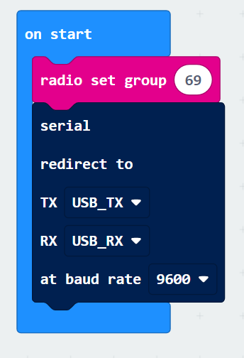
- Now we're going to use the basic block "forever"; go to Serial and place the block "serial write value =" in the forever block:
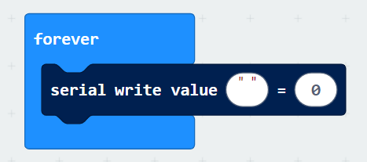
- Create a new variable and name this “temperature”, put it in the last value. Go to basic and place the "pause (ms)" block, set it to 2000 and place it under the serial block:
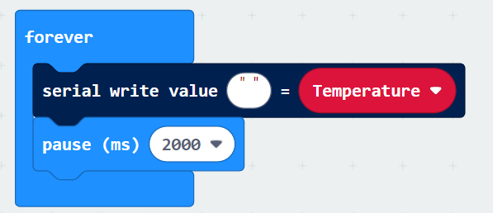
Be careful, you have to leave the write value blank in order to receive the right data. Therefore, the value should say " ", followed by the value that should be sent to Excel, in this case temperature. Don't leave any text, because then Excel will also import the value as text and it can't be edited in Excel.
- The final step is to receive the radio signal. Go to radio and place the block "on radio received receivednumber" and place it in the work field:
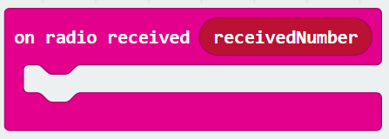
- Go to Variables and place the block "set temperature to" in the aforementioned block. Set the value 0 to the variable "receivednumber":
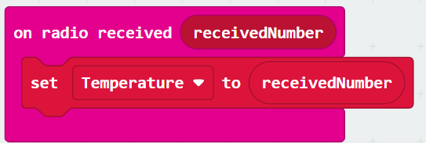
- In the example Micro:bit you will see a bar appear under the Micro:bit with "show data simulator": .
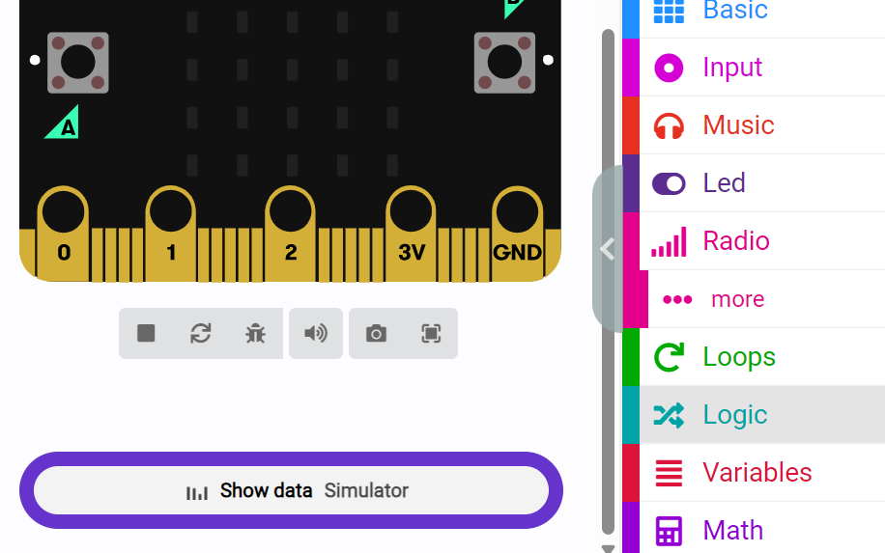
- If you click on it, you will see that the minicomputer shows a constantly moving graph, but the Micro:bit does not receive a signal yet. For that, we need the previously prepared Micro:bit. We also need to do some preparatory steps in Excel. But if you're happy with your code, you can download it on the second Micro:bit.
Go to paragraph 3.8.1. to establish a connection between the Micro:bit and Excel. When you have done everything, you can have the 1st micro:bit send the temperature to the 2nd micro:bit that you have connected to your laptop. Excel will now show the temperature in a graph. And how hot or cold is it in the room where you have placed the sender?

4.4 Who’s the fastest?
You carry out this project in pairs, which of you is the fastest? The goal of the project is to create a board game in which, as soon as you see a signal on the micro:bit, you touch the touchpads as quickly as possible. You have to keep touching the starting point with your other hand.
Equipment
- Micro:bit
- Carboard
- Aluminium foil
- Markers
- 4 crocodile clamps
- Tape
Method
Creating the game board
- Cut a piece of cardboard 10 x 20 cm
- Cut out pieces of aluminium foil and attach them to the corners of the cardboard
- Attach each piece of foil to the correct pin of the Micro:bit
- Make sure your game board will look something like this

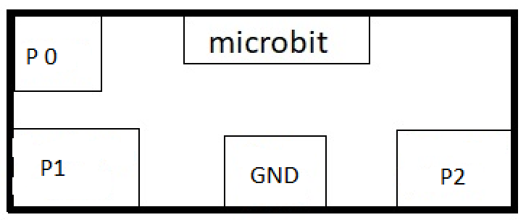
Code
- Create a new project

- Go to Variables and create 4 different variables; start, valse_start, running and end:
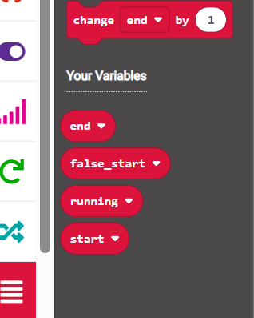
- For the variables, set running and valse_start the value as "false". You can find these under the "Boolean value" heading:

- We are now going to set the pins, go to input and choose "on pin P0 pressed" and place it in your work field:
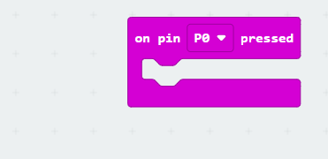

- We are going to let the game count down, we do this by going to basic and entering the block "show number" three times, and let it count down:
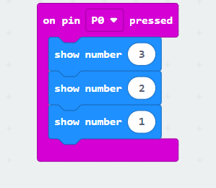

- Then we want the screen to be erased, we do this by choosing the "clear screen" block at basic:
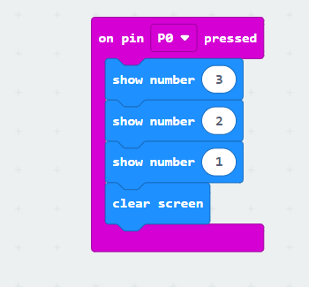

- Now we are going to enter our variable running and false start , as we have already set it in the "on start" block:
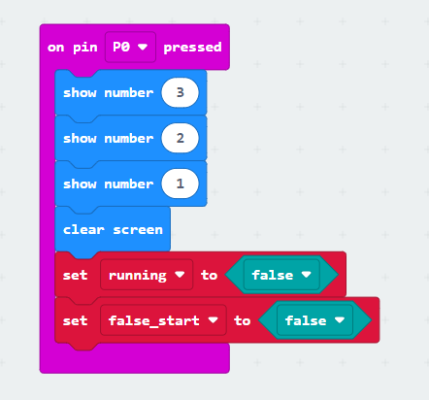
- Now that we've established this, let's give the Micro:bit a pause. The participants have to wait until the game starts and if we let this happen randomly, the game cannot be predicted. We do this by choosing the block "pause (ms)" for basis and "0 + 0" under math. Set the first value to 1000 and then add the block "pick random 0 to 10" to the 2nd value:
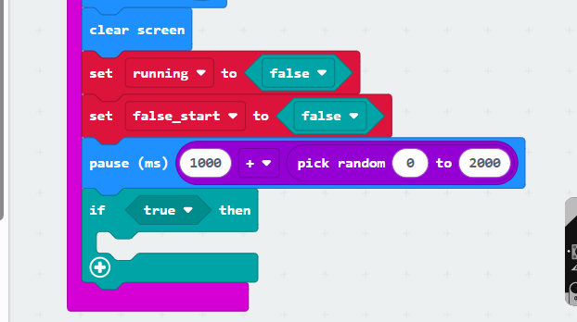
Set the value of the "randomly choose 0 to 10", the last value to 2000. With this, we set the waiting time to a time between 1 and 2 seconds.
- Now we're going to apply the "if true then " function of logic. Add the block "not ..." to the value and place the variable "false start" in the aforementioned, make sure you end up with the following:
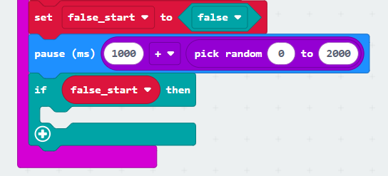
- Now we're going to set up what happens if no false start is made. Choose the "set start to " variables and place the block "running time (ms)" which you can find in input:
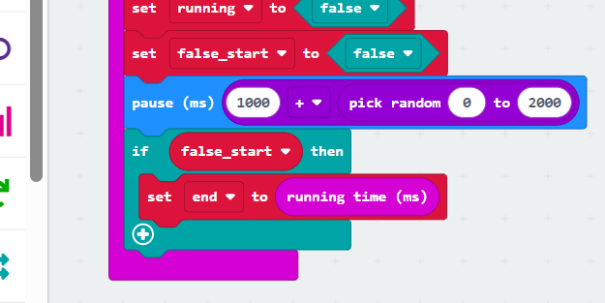
- Go to variables and again place a "set running on" and place it below the previous one. Make sure you set it to “true”. Now go to Led and click on the 3 dots to finally add the block "stop animation:
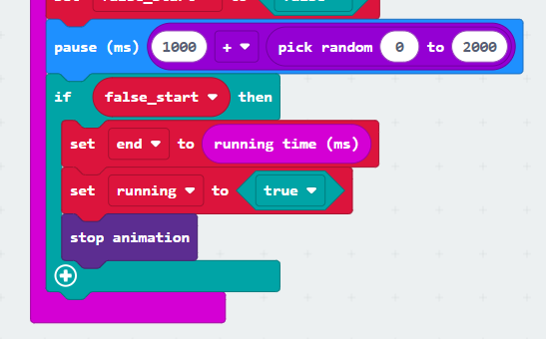

- Now go to the basic and add the "clear screen" block. After that, go to Led and choose the block "plot x 0 y 0 ". Place it under clear screen:
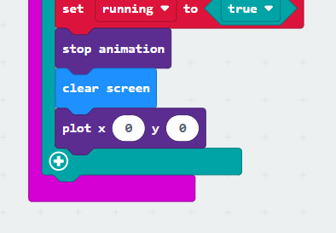
- Finally, go to math and choose the block "pick random 0 to 10" and set the 10 to a 4. Do this for both the x and y values:
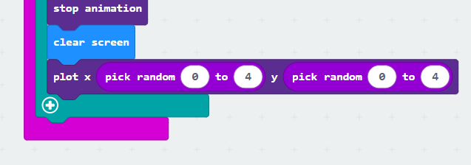
- Now we have set P0, the other pins (P1 and P2) are surfaces in the game that will be touched. This is done in a similar way. Go to input and choose the block "on pin is touched" and place it in the work area. Then go to Logic and choose the "if true then else" and place it in the pink block:
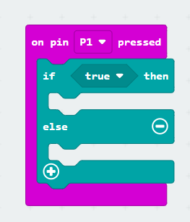
- Change the value to the variable "running". After that, place 2x the "set variable to " under the if/then option. Set the first to running and the second to end. The running value should be set to false, which is why we are going to add the block "false". The end must be set when the running time is added, hence the block "running time (ms)". In the end, you should get the following code:
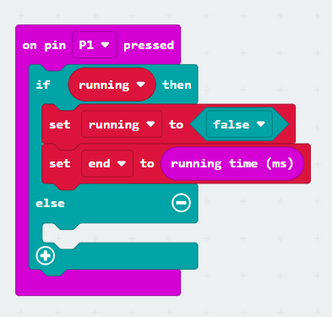
- Now we are going to set the Micro:bit to show lights on the left side (this side the participants should then try to touch as quickly as possible). Go to basic and choose the "show leds" block, make sure the left side of the screen is lit up and then place a pause block and set it to 1 second:
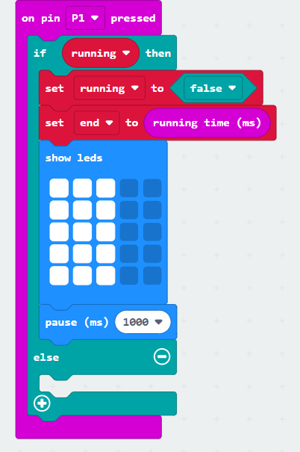

- Next we show the time, we do this by adding the block "show number" under the code to the basic. Then go to math and place "0 – 0" in the block. Change the values in the end and start variables:
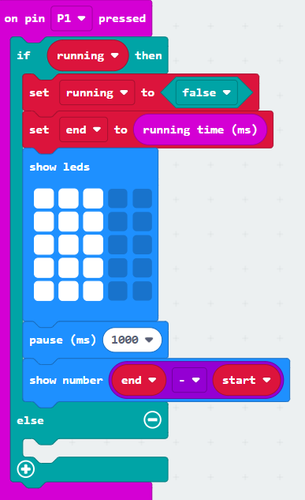
- We now also have to show something if a false start has been made, we do this by writing the following in else. Go to variables and put "set false start to " place it in the block. Make sure the variables are set to true (found at logic). After that, add the "show leds" from basic and make an X appear:
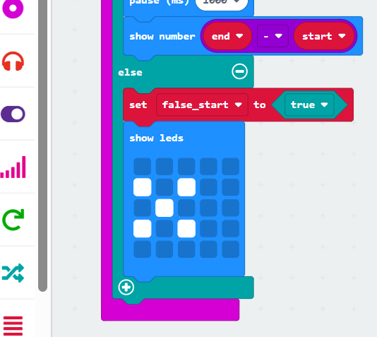
- Finally, we are going to set P2, which is basically the same because we can copy the code. So copy the code from P1 and place it in your work field. Make sure you change the P1 to P2. And move the lights on the right:
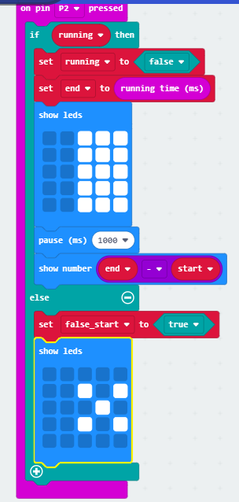
- When your code is ready, you can download it. Now connect the alligator clips to the Micro:bit and the game board and play! Who won?

Final project
For the final assignment, you will devise and write a program for the Micro:bit yourself. You can decide for yourself what the goal of your program should be, you can think of an application in a measurement setup, a game, a handy tool, an art object, the possibilities are endless. For inspiration, you can use https://makecode.microbit.org, YouTube or other websites. Please note! The idea is that you produce and make the code yourself.
Requirements
The final assignment must meet the following:
- You form an idea for a program and have it approved by your teacher/TOA.
- You write a program for a Micro:bit on https://makecode.microbit.org
- Your program uses at least one input, one processing and one output (see further explanation below).
- Your program uses at least 1 Micro:bit. In addition, you can also use multiple Micro:bits, external sensors and the Grove Shield. Consult with your teacher/TOA if you want to make use of this.
- You explain the operation of your program based on a poster in A4 format. The poster contains at least the name of your project/program, explained in a few sentences what the purpose of your program is and how it works, a diagram containing the input, processing, and output of your program.

Presentation
You will present and demonstrate your program during class. To do this, you bring a laptop with the code you wrote, the Micro: bit(s) and any external sensors and devices. You also bring the poster with you that explains your program.
Input, processing and output
Before you start writing your code you must produce a plan. This plan should involve the following:

Input: The program you are going to write must work with an input. This means that you have to enter information into your program in a certain way. This can be done in various ways, for example by pressing a button on the Micro:bit, by measuring with an (external) sensor, by receiving a radio signal from another Micro:bit, etc. For more examples and explanations, you can watch the following video: https://youtu.be/NkoS2JXaBuM

Processing: Next, your program has to do something with the information that has been entered (with the input). Here too, the possibilities are endless. Which processing is needed depends entirely on the idea you have come up with. To get the processing done, you have to write code in https://makecode.microbit.org/. You may use the building blocks to create your code.
Output: The program must then also give output. This means that, after the input has been processed in your program, information must come out of your program again. This can be, for example, an image, number or text on the LED screen of the Micro:bit, a radio signal to another Micro:bit, an external device such as a laptop or speaker, etc. For more examples and explanations, you can watch the following video: https://youtu.be/NkoS2JXaBuM

Example: Below is an example of a simple program set out in input, processing, output.

Voorbeeld:
Hieronder

Assessment
Your program will be judged according to the rubric below:
Rubric Final project Micro:bit
 |  | Maximum amount of points | Achieved points
Creative and original idea |  | 3
Effective and efficient code |  | 3
Good explanation of program via poster |  | 2
Meets minimum requirements  (input, processing, output and 1 micro: bit) |  | 2
Total points |  | Grade

