Experiment Frictional Force – TTO 3

Aim
The aim of this experiment is to find out how different materials influence the kinetic friction on a moving block.

Equipment
- Block with different materials on the sides
- Rope
- Pulley
- Clamp
- Weight of 50 g
- Scale
- Ruler
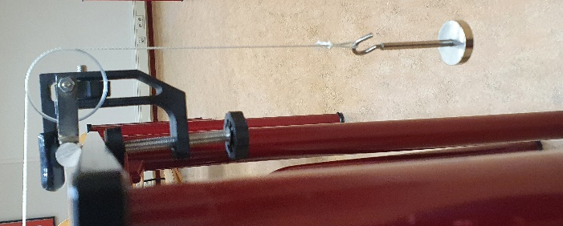
- Stopwatch
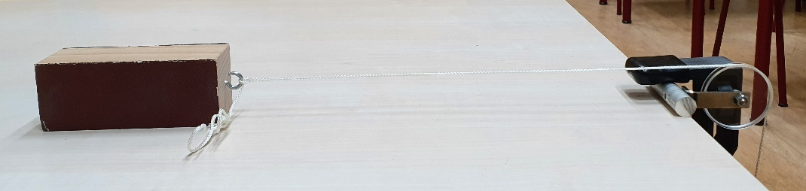
Execution
- Measure the mass of the block.
- Build the setup from the images.
- Make sure the block is against the pulley when the weight is on the ground. The rope should be tight in this situation.
- Pull the block as far as possible away from the pulley and measure the distance between the block and the pulley.
- Release the block and measure the time between release and the block hitting the pulley.
- Do the measurement of step 5 three times. Make sure the block is laying on the table with the same side for every measurement.
- Turn the block so another material is on the table and repeat steps 5 and 6. Make sure to completely fill out table 1.

Calculations
- Calculate the average velocity of the block.
- Calculate the acceleration of the block.
- Calculate the resultant force that works on the block.
- Calculate the force of tension that works on the block.
- Calculate the force of friction on the block.
- Fill in your answers in table 2.

Results

m_{block} = ………… kg

Δx = ………… m

F_{tension} = F_{z} = ………… N
Material | Time measurement 1 (s) | Time measurement 2 (s) | Time measurement 3 (s) | Δt average (s)
Wood
Sandpaper
Felt

Table 1: Time measurements
Material | v_{avg} (m/s) | v₂ (m/s) | Δv (m/s) | a (m/s²) | F_{res} (N) | F_{f} (N)
Wood
Sandpaper
Felt

Table 2: Calculations

Conclusion
What can you say about the different frictional forces from the different materials?

